## CSE585/EE555:  Digital Image Processing II

## Computer Project # 3:

#### Nonlinear Filtering and Anisotropic Diffusion

#### Sweekar Sudhakara, Prapti Panigrahi, Savinay Nagendra, Nagarjuna Pampana,

#### Date: 03/28/2021

1. **Objectives**

The Objective of this project is two-fold. The objective of the first part is to implement and iteratively observe the effect of multiple non-linear filters on a given image. In this project we implement the following five filters: Mean, Median, Alpha-trimmed, Sigma and Symmetrical Nearest Neighbor Mean. For every filter, we qualitatively and quantitatively observe how effectively it can remove added noise in the image using histograms. The goal is to observe how the histograms of filtered images clearly show discrete boundaries indicating the reduction of noise levels in gray scale images. The objective of the second part is to understand and implement the process of anisotropic diffusion of an image so as to remove noise within the image. The process involves computing gradients, conduction coefficients and histograms of an image. We get to learn how the number of iterations, the function of “g” and the value of “k” within “g” effect the final result of anisotropic diffusion. The goal is to gain a better understanding of these underlying concepts and reconstruct a better (less noisy) version of the uncorrupted image from a corrupted (noisy) image.

1. **Methods**

**Theory and Algorithms:**

The process flow followed in the project implementation (both parts) is as follows:

**PART 1: Nonlinear filtering**

**Top-level goals** of the method are:

1. Read the given image.
2. Implement the following filters: Mean, Median, Alpha-trimmed, Sigma and Symmetrical Nearest Neighbor Mean.
3. Apply these filters on the given image for 5 iterations and visually (qualitatively) observe the effect of each filter in the reduction of noise levels at the first and the fifth iterations.
4. Compute histograms of filtered images at first and fifth iterations to observe the gray scale intensity distributions as the image is iteratively filtered.
5. Compute mean and standard deviation values of the large disk in filtered images at the first and fifth iterations to make quantitative observations.

**Details** of the method are:

1. **Mean Filter**
   1. Mean filter for 1-D image array $\{x_{k-M},…x_{k},…, x_{k+M}\}$ is given by:

$$y_{k}= \frac{1}{2N+1}\sum_{i=1}^{2N+1}{x_{k-N-1+i}}$$

where the window size is given by $n=2N+1$, as given in L12-5.

* 1. Equation of mean filter indicates that the value of $x_{k}$ is replaced by the average of intensities of its $2N+1$ neighbors.
  2. We use this formula for 2D images where our sliding window is of size

).

* 1. Image is padded with $N$ zeros on all sides to avoid loss of information at boundary pixels.
  2. Mean of all pixels inside the sliding window is used for the intensity of the filtered image at location $(N+1, N+1)$.
  3. Window is sided by 1 pixel and Step e. is repeated until all the pixels in the image are covered.

1. **Median Filter**
   1. For a 1-D image $\left\{x_{k-M},…x_{k},…, x_{k+M}\right\}$ with $2M+1$ pixels, median filter of window size $N$ is applied at pixel $k$ will first sort all pixels in ascending order and the middle element (if $N$ is odd) or the mean of the two center elements (if $N$ is even) is the value at $k$ of the filtered image. The equation for the median filter after sorting is $y_{k}=x_{N+1}$ For our case of 2D images, we use a window of size $(2N+1 X 2N+1$).
   2. Image is padded with $N$ zeros on all sides to avoid loss of information at boundary pixels.
   3. Median of all pixels inside the sliding window is used for the intensity of the filtered image at location $(N+1, N+1)$.
   4. Window is sided by 1 pixel and Step c. is repeated until all the pixels in the image are covered.
   5. We use MATLAB’s inbuilt function called ***medfilt2( )***to compute the median filtered images.
2. **Alpha-trimmed mean filter**
   1. According to the equation given in L12-4, alpha-trimmed mean filter is given by:

$$y_{k}=\left(\frac{1}{n-2\left\lfloor αn\right\rfloor }\right)\sum_{i=\left|αn\right|+1}^{n-\left|αn\right|}{x_{(i)}}$$

where $x_{(i)}=$ ordered set of inputs and window length is $n=2N+1$ and $0≤ α≤0.5$. This is for 1-D images.

* 1. For a 2-D image, we use a sliding window of size ).
  2. Above equation is applied using all pixels inside the sliding window and the intensity of the filtered image at location $(N+1, N+1)$ is computed.
  3. Window is sided by 1 pixel and Step c. is repeated until all the pixels in the image are covered.
  4. Image is padded with $N$ zeros on all sides to avoid loss of information at boundary pixels.

1. **Sigma filter**
   1. For a 1-D image $\left\{x_{k-M},…x_{k},…, x_{k+M}\right\}$ with $2M+1$ pixels, the filtered pixel’s intensity at $k$ after applying the sigma filter is given by

$$y_{k}=\frac{1}{N_{c}}\sum_{i=-N}^{N}{δ_{i}x_{k-i}}$$

where, $δ_{i}=\left\{\begin{aligned}1, |x_{k-i}-x_{k}| <= 2σ \\ 0, otherwise\end{aligned}\right.$

and $N_{c}≜$ Number of points $x_{k-i}$ having $δ_{i}=1$.

1. This is for 1-D images. For a 2-D image, we use a sliding window of size $(2N+1 X 2N+1$).
2. Above equation is applied using all pixels inside the sliding window and the intensity of the filtered image at location $(N+1, N+1)$ is computed.
3. Image is padded with $N$ zeros on all sides to avoid loss of information at boundary pixels.
4. Window is sided by 1 pixel and Step b. is repeated until all the pixels in the image are covered.
5. **Symmetric Nearest Neighbor Mean filter**
   1. As the name suggests, pairs of pixels are formed using symmetrically opposite pixels inside the sliding window of size $(2N+1 X 2N+1$).
   2. If the pixel on which SNN filter is to be applied is $p_{k}$ with intensity $v_{k},$ the pixels among the pairs which are closest to $p_{k}$ are chosen, i.e.,

$p_{i} = \underset{v_{j}: j = \{1,2\}}{\underbrace{argmin}} \{ |v_{j} - v_{k}| \}, ∀ i = 1, 2, ..., \frac{{(2N+1)}^{2}}{2}$ (all symmetrical pairs)

* 1. In every pair, we get one pixel’s intensity that is closest to the intensity of the middle pixel. The average of all these selected pixels is taken.
  2. The mean of the averaged value and the original middle pixel value is assigned to that pixel in the filtered image.
  3. Image is padded with $N$ zeros on all sides to avoid loss of information at boundary pixels.
  4. Window is sided by 1 pixel and Steps c and d. are repeated until all the pixels in the image are covered.

1. **Calculation of Mean and Standard deviation of large disk**

We are needed to calculate the mean and standard deviation of the interior of the largest disk in the given image – *disk.gif*. The *imtool* functionality of MATLAB was used to find the pixel coordinates of an interior region of the larger disk. This region was chosen and the mean and standard deviation of these pixels were calculated.

**PART 2: Anisotropic Diffusion for Image Filtering**

**Top-level goals** of the method are:

1. Read the image and compute its histogram.
2. Implement anisotropic diffusion algorithm, with a conduction coefficient based on exponential and inverse quadratic functions, for different values of ‘k’ until 100 iterations.
3. Within the iteration of step (2), clip images at 5th, 20th and 100th iterations to see how the algorithm develops. Also take their histograms and plot the line ‘y = 128’ for each image.
4. Segment the spokes component of the clipped images from step (3) by manual thresholding.

**Details** of the method are:

1. Read the image and compute its histogram: Read the image and compute its histogram using the in-built MATLAB function **imhist.m**.
2. Implement anisotropic diffusion: The anisotropic diffusion is defined as:

$I_{i,j}^{t+1}=I_{i,j}^{t}+λ{\left[c_{N}^{t}∇_{N}I+c_{S}^{t}∇_{S}I+c_{E}^{t}∇_{E}I+c_{W}^{t}∇_{W}I\right]}_{i,j}^{t}$**(1)**

Here, $λ=0.25$, $∇_{N}I_{i,j}^{t}=I_{i,j+1}^{t}-I_{i,j}^{t}$ (gradient in the north direction)

$∇_{S}I_{i,j}^{t}=I_{i,j-1}^{t}-I_{i,j}^{t}$ (gradient in the south direction)

$∇_{E}I_{i,j}^{t}=I_{i+1,j}^{t}-I_{i,j}^{t}$ (gradient in the east direction)

$∇_{W}I_{i,j}^{t}=I_{i-1,j}^{t}-I_{i,j}^{t}$ (gradient in the west direction)

The north exponential conduction coefficient is ${\left[c_{N}\right]}_{i,j}^{t}=e^{-{\left(\frac{∇_{N}I_{i,j}^{t}}{k}\right)}^{2}}$, the south exponential conduction coefficient is ${\left[c_{S}\right]}_{i,j}^{t}=e^{-{\left(\frac{∇_{S}I_{i,j}^{t}}{k}\right)}^{2}}$, the east exponential conduction coefficient is ${\left[c_{E}\right]}_{i,j}^{t}=e^{-{\left(\frac{∇_{E}I_{i,j}^{t}}{k}\right)}^{2}}$, and the west exponential conduction coefficient is ${\left[c_{W}\right]}_{i,j}^{t}=e^{-{\left(\frac{∇_{W}I_{i,j}^{t}}{k}\right)}^{2}}$.

The value of **k is chosen to vary from 20 to 40 at steps of 10** for the exponential conduction coefficient. However, for the inverse quadratic conduction coefficient, the **k is chosen as (6, 8, 9)** based on the trial and experimentation. In addition, we have placed the results with other values of ‘k’ for both the coefficients in the ‘/Results/’ folder.

For the conduction coefficient based on inverse quadratic function, it is defined as:

The north inverse quadratic conduction coefficient is ${\left[c_{N}\right]}_{i,j}^{t}=\frac{1}{1+{\left(\frac{∇_{N}I_{i,j}^{t}}{k}\right)}^{2}}$, the south inverse quadratic conduction coefficient is ${\left[c_{S}\right]}_{i,j}^{t}=\frac{1}{1+{\left(\frac{∇_{S}I_{i,j}^{t}}{k}\right)}^{2}}$, the east inverse quadratic conduction coefficient is ${\left[c_{E}\right]}_{i,j}^{t}=\frac{1}{1+{\left(\frac{∇_{E}I_{i,j}^{t}}{k}\right)}^{2}}$, and the west inverse quadratic conduction coefficient is ${\left[c_{W}\right]}_{i,j}^{t}=\frac{1}{1+{\left(\frac{∇_{W}I_{i,j}^{t}}{k}\right)}^{2}}$.

Using the equation (1) we can compute anisotropic diffusion for 100 iterations by choosing the conduction coefficient to be either exponential function or inverse quadratic function.

1. Clipping the images and plotting the histogram: When iterating for 100 times using equation (1) we sample the images at iterations 5,20 and 100. Sometimes the equations give values greater than 255 or less than 0 at a pixel. We need to limit them to 255 or 0 accordingly and sample the images at the above said iterations. This sampling lets us see how the images evolve over time. Once we get the clipped images; we plot their histograms and also plot the line y=128 of each image. The histogram gives us an idea about how the grey level values are spread out and their variances and the plot of line y=128 lets us see how the algorithm smooths out the inter-region pixel over time.
2. Segment the spokes component: We proceed to segment the spokes region of the images by thresholding values between the grey-scale values 120 and 80 to a binary image. This lets us see how a specific region evolves over time.

**MATLAB:**

The MATLAB implementation followed in the project (both parts) is as follows:

**PART 1: Nonlinear Filtering**

The files corresponding to Nonlinear Filtering (PART 1) can be found in the folder **EE555_Project_3/Part_1/**. The main code file for the PART 1 is **main.m**.

In Figure 2, we can observe the flowchart followed in the MATLAB implementation for PART 1: Nonlinear Filtering.

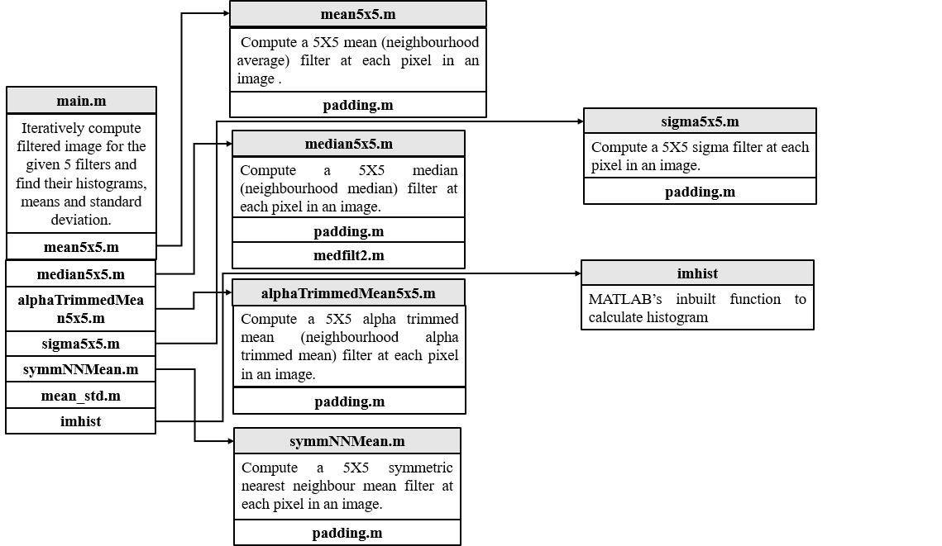

**Figure 2**: Flowchart depicting the code implementation of PART 1: Nonlinear Filtering (**main.m**).

**NOTE**: In order to obtain the results as shown in the next section kindly execute/run the **main.m** code file located in **EE555_Project_3/Part_1/**.

* **main.m** file takes image *disk.gif* as input and iteratively applies the five filters mentioned in the previous section. For iterations 1 and 5, histograms of the filtered images are calculated using MATLAB’s **imhist** function to observe the noise removal and distinct boundaries. Mean and Standard deviations for an interior region of the large disk are calculated for iterations 1 and 5. The internal structure of files in PART 1 are described below with functionalities.
  1. **mean5x5.m** computes the mean (neighborhood average) filter at each pixel in an image. It takes as input the *uint8* casted image. The function uses a sliding window of size 5x5. The image is padded with 2 pixels on all sides using **padding.m** to avoid loss of information at boundaries. The function slides the sliding window over the entire padded image until all pixels are covered. At each step, mean of the neighborhood pixels are calculated and set as the pixel value of the corresponding pixel in the filtered image.
  2. **median5x5.m** computes the 5x5 median filter at each pixel in an image. It takes as input the *uint8* casted image. The function uses a sliding window of size 5x5. The image is padded with 2 pixels on all sides using **padding.m** to avoid loss of information at boundaries. MATLAB’s **medfilt2.m** is used to calculate the median filtered image.
  3. **alphaTrimmed5x5.m** computes a 5x5 alpha-trimmed mean filter at each pixel in an image. It takes as input the *uint8* casted image. The function uses a sliding window of size 5x5. The image is padded with 2 pixels on all sides using **padding.m** to avoid loss of information at boundaries. The value of each pixel inside the sliding window is stored in an array. This array is sorted. The mean of the sorted values in a sub-window is calculated and set as the average value of the corresponding pixel in the filtered image.
  4. **sigma5x5.m** computesa 5x5 sigma filter at each pixel in an image. It takes as input the *uint8* casted image. The function uses a sliding window of size 5x5. The image is padded with 2 pixels on all sides using **padding.m** to avoid loss of information at boundaries. Value of each pixel is subtracted from the value of the middle pixel in the sliding window. If the difference is less than or equal to the given sigma, that pixel’s value is added to a temporary variable. Finally, this sum is divided by the number of pixels considered, which is the final value of the corresponding pixel in the filtered image.
  5. **symmNNMean.m** computes a 5x5 symmetric nearest neighbor mean filter at each pixel in an image. It takes as input the *uint8* casted image. The function uses a sliding window of size 5x5. The image is padded with 2 pixels on all sides using **padding.m** to avoid loss of information at boundaries. Symmetrical pairs of pixels are grouped together, and their values are compared with that of the middle pixel. Based on this absolute difference, pixels with minimum difference in each pair is chosen and their values are added to a temporary variable. The average of all these pixels is taken and the mean of this average and the value of the middle pixel is the value of the corresponding pixel in the filtered image.
  6. **mean_std.m** computes the mean and standard deviation of the interior region of the large disk. The pixel coordinates of this regions are obtained by using MATLAB’s inbuilt **imtool** functionality. **mean2** and **std2** functions are used for the calculations.

**PART 2: Anisotropic Diffusion for Image Filtering**

The files corresponding to Anisotropic Diffusion for Image Filtering (PART 2) can be found in the folder **EE555_Project_3/Part_2/**. The main code file for the PART 2 is **main.m**.

In Figure 3, we can observe the flowchart followed in the MATLAB implementation for PART 2: Anisotropic Diffusion for Image Filtering.

**NOTE**: In order to obtain the results as shown in the next section kindly execute/run the **main.m** code file located in **EE555_Project_3/Part_2/**.

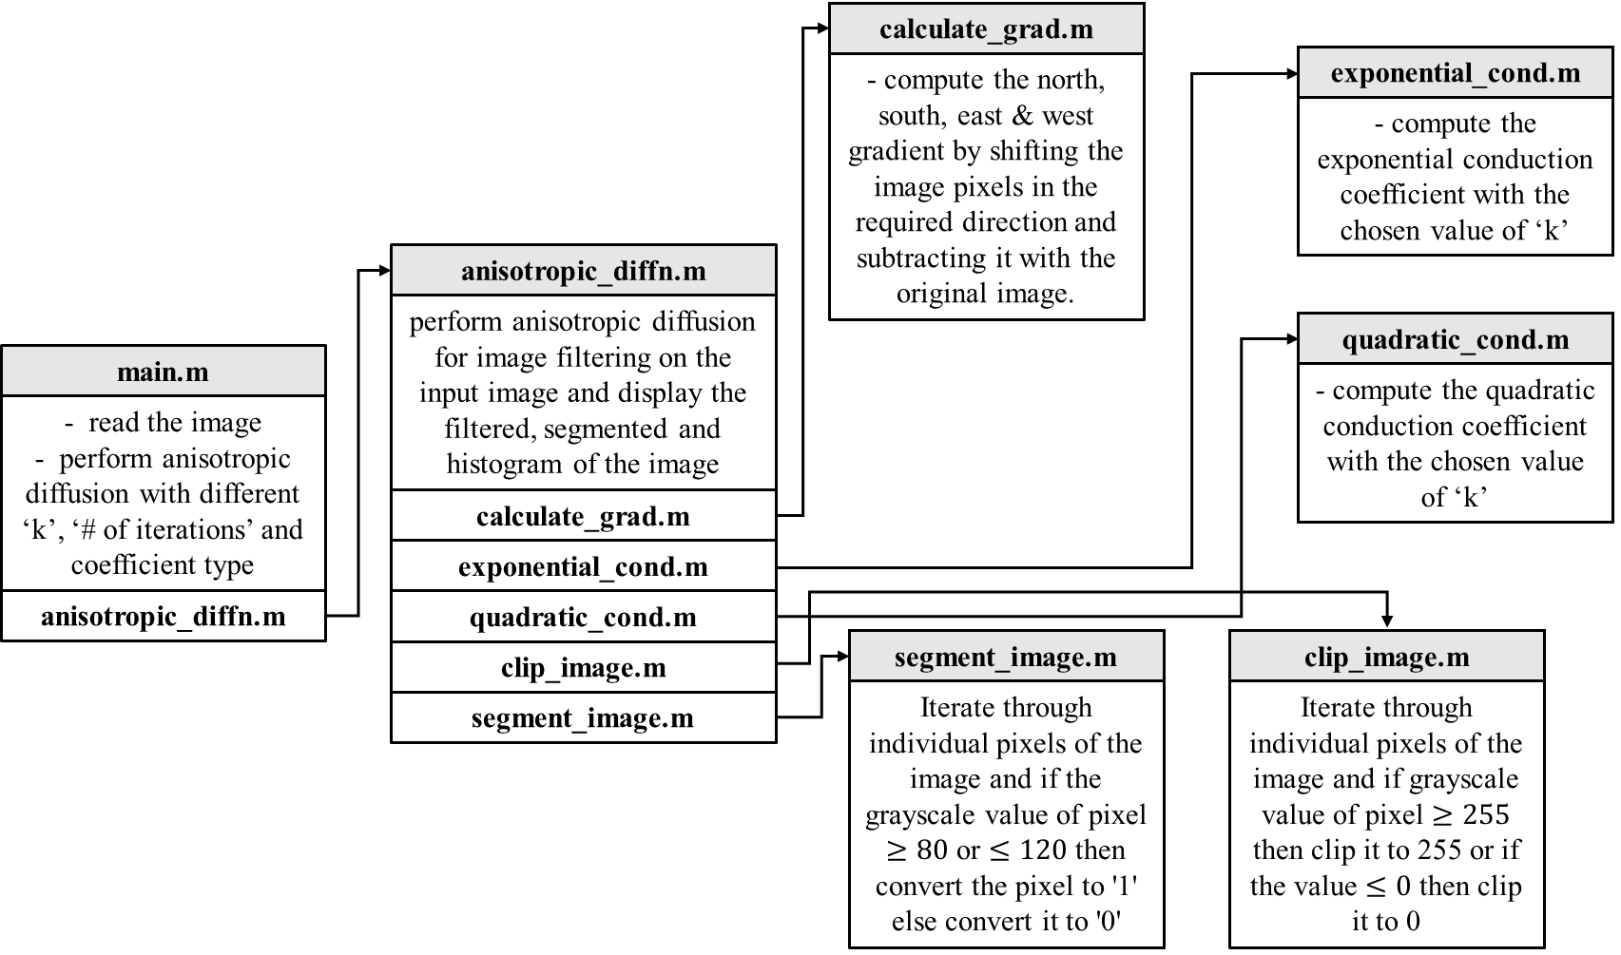

**Figure 3**: Flowchart depicting the code implementation of PART 2: Anisotropic Diffusion for Image Filtering (**main.m**).

* **main.m** file takes the image file name (*‘cwheelnoise.gif’*) and (*‘cameraman.tif’*) as inputs and removes the noise in these images using anisotropic diffusion. It works as listed below:

1. It calls **anisotropic_diffn.m** function with following as the input arguments: image converted to double format, string with image name, maximum number of iterations, value of λ and the function used for conduction coefficient.
2. The **anisotropic_diffn.m** function gives us an image with anisotropic diffusion applied for 100 iterations. For each iteration it calls **calculate_grad.m** function with the current image as an input to get north, south, east and west gradients of the current image. Once the gradients are obtained it calls yet another function **exponential_cond.m** or **quadratic_cond.m** basedon the input arguments given to **anisotropic_diffn.m**. these functions take the north, south, east and west gradients as input and gives north, south, east and west conduction coefficients as an output. Once the conductions coefficients are obtained the diffused image is calculated according to the equation (1) . at the end of each iteration the current image is replaced by the diffused image. Over the course of iterations, the images at iteration 5, 20 and 100 are sampled by calling the function **clip_image.m** which takes diffused image as the input and converts it into a properly formatted image by restricting the grey-scale values between 0 and 255. According to the input arguments given to the **anisotropic_diffn.m**,it checks whether the input given input is *‘cwheelnoise.gif’ or ‘cameraman.tif’* using **strcmp.m** in-built MATLAB function to decide whether to further compute histogram, segmentation and plot y=128. If the image is *‘cwheelnoise.gif’,* then **anisotropic_diffn.m** function proceeds to call in-built function **imhist.m** to plot a histogram of the image and plots the line y=128 of the images sampled at iterations 5, 20 and 100. Later on it calls **segment_image.m** function with sampled image as the input to segment the spokes and convert it into a binary image. All the image outputs are then saved using **imwrite.m** in-built MATLAB function.
3. The **calculate_grad.m** shiftsthe image by 1 pixel in north, south, east and west directions and subtracts it from the original image to get the north, south, east and west gradients respectively.
4. The **exponential_cond.m** and **quadratic_cond.m** functions takes the north, south, east and west gradients and computes the north, south, east and west conduction coefficients using their respective equations shown in the above sections.
5. The **clip_image.m** function takes diffused image as the input and converts it into a properly formatted image by clipping values below and beyond 0, 255 grey-scale values and restricting them to 0 and 255 respectively.
6. The **segment_image.m** function takes sampled image as an input and threshold the values between the grey-scale values 80 and 120, to retain the spokes region and assigns them value 1 in a binary image and the rest of the regions are made background (value 0).
7. **Results**

In this section we discuss about the results corresponding both parts of the project.

**PART 1: Nonlinear Filtering**

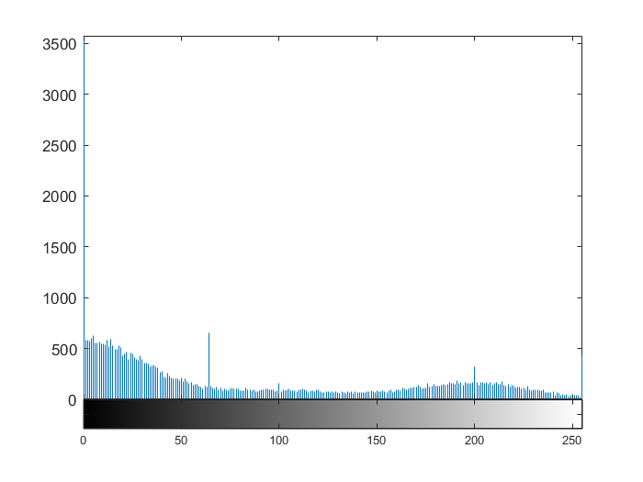All the five filters discussed in the Methods section were applied to the *disk.gif* image. The original image is shown in Figure 1 and its histogram is shown in Figure 2. The interior of the largest disk chosen for our calculations is shown in Figure 3. The coordinates used were *disk.gif* [60:170, 62:132]. The mean of the largest disk before filtering is 196.0456 and the standard deviation is 33.9550.

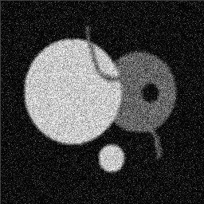

**Figure** **1:** Original image (*disk.gif)* **Figure 2:** Histogram of original image

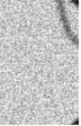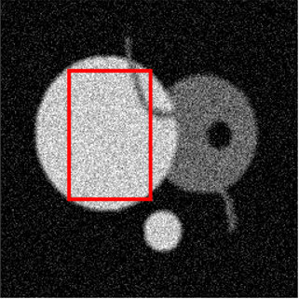Each filter was recursively applied for five iterations on the image. The results below provide the filtered images and corresponding histograms at the end of first and fifth iterations. The sliding window size used for all filters is 5x5.

**Figure** **3:** Interior region of Largest disk in the image (*disk.gif*)

* 1. **Mean Filter**

A 5x5 mean filter was applied on the image shown in Figure 1. The filter was recursively applied for 5 iterations where each pixel value was replaced with the mean of the pixels in the sliding window. Figures 4(a), 4(b) and 5(a), 5(b) show the filtered image and histogram at the end of first and fifth iterations, respectively.

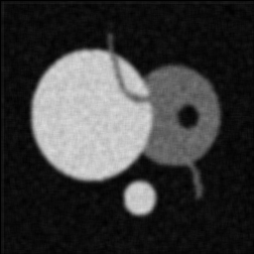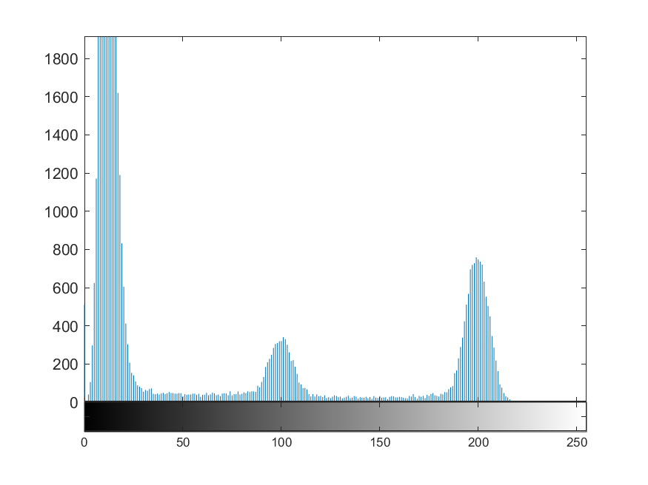

**Figure 4(a):** Mean Filtered image (iteration 1)  **Figure 4(b):** Histogram (iteration 1)

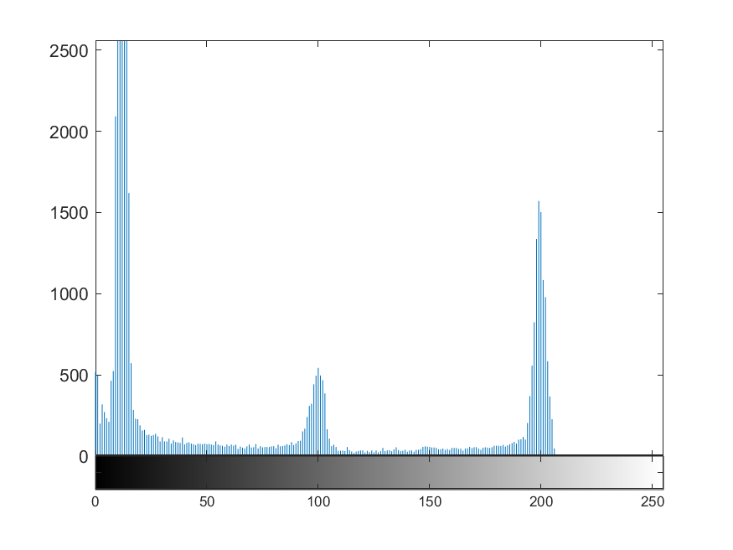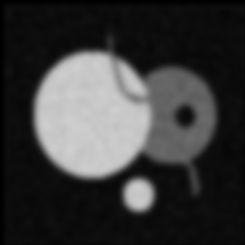

**Figure 5(a):** Mean Filtered image (iteration 5)  **Figure 5(b):** Histogram (iteration 5)

Mean and Standard deviation of the largest disk after iteratively applying the mean filter is shown in Figure 6.

|  |  |  |
| --- | --- | --- |
| **Iteration** | **Mean** | **Standard Deviation** |
| **1** | **196.061667** | **16.980550** |
| **5** | **194.529374** | **18.636121** |

**Figure 6:** Tabular results of Mean and Standard Deviation of the largest disk.

**Observation**:

From Figures 4 and 5, it can be observed that the noise levels are reducing in the filtered image with iterations. We also observe the blurring effect of the mean filter in iteration 5 (Figure 5), although the noise is completely reduced. This is an undesirable effect of the mean filter where distinct boundaries are clearly not preserved, i.e., there is a loss of edges after filtering. The means and standard deviation values decreases with iterations when compared to the original image (Figure 1). The decrease in standard deviation is a desirable effect showing that the data is clustered around the mean, rather than spread out, as seen in Figure 2. It also clearly indicates that distinct gray levels are well represented in the filtered images in the form of spikes with clear boundaries/edges.

* 1. **Median filter**

A 5x5 mean filter was applied on the image shown in Figure 1. The filter was recursively applied for 5 iterations where each pixel value was replaced with the median of the pixels in the sliding window. Figures 7(a), 7(b) and 8(a), 8(b) show the filtered image and histogram at the end of first and fifth iterations, respectively.

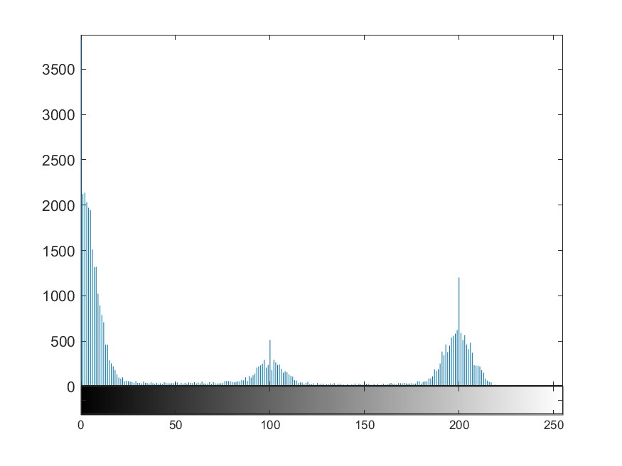

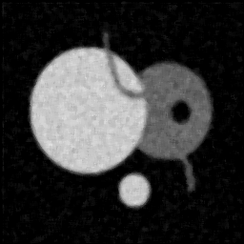

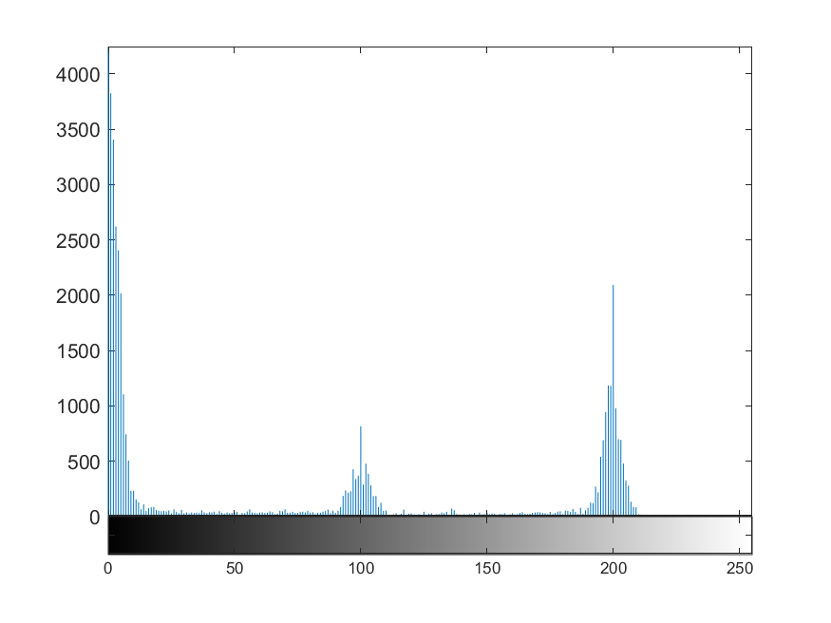**Figure 7(a):** Median Filtered image (iteration 1) **Figure 7(b):** Histogram (iteration 1)

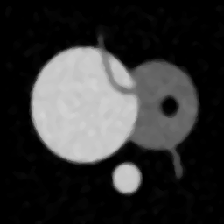

**Figure 8(a):** Median Filtered image (iteration 5) **Figure 8(b):** Histogram (iteration 5)

Mean and Standard deviation of the largest disk after iteratively applying the mean filter is shown in Figure 9.

|  |  |  |
| --- | --- | --- |
| **Iteration** | **Mean** | **Standard Deviation** |
| **1** | **196.330796** | **17.908554** |
| **5** | **195.296790** | **20.424694** |

**Figure 9:** Tabular results of Mean and Standard Deviation of the largest disk.

**Observation:**

The filtered images in Figure 7(a) and 8(a) are no longer grainy, indicating the removal of noise. Edges are preserved, unlike the mean filter. The histograms in 7(b) and 8(b) show clear peaks. The peaks are higher than that of the mean filter.

* 1. **Alpha-trimmed Mean filter (ATM filter)**

A 5x5 alpha-trimmed mean filter with $α=0.25$ was applied on the image shown in Figure 1. The filter was recursively applied for 5 iterations where each pixel value was replaced with the value obtained from the ATM equation in Methods section using the pixels in the sliding window. Figures 10(a), 10(b) and 11(a), 11(b) show the filtered image and histogram at the end of first and fifth iterations, respectively.

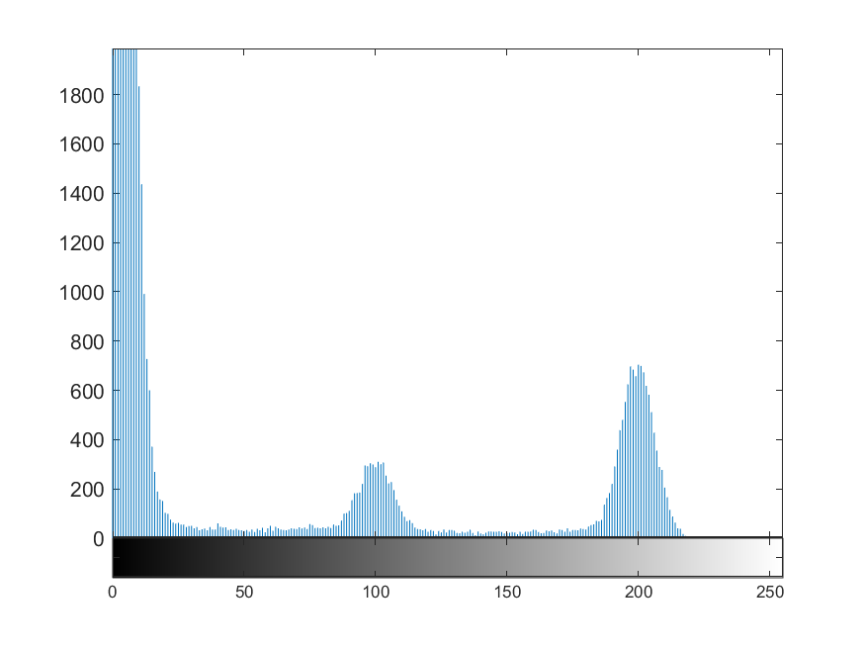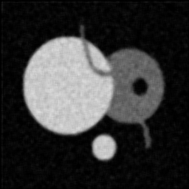

**Figure 10(a):** ATM Filtered image (iteration 1) **Figure 10(b):** Histogram (iteration 1)

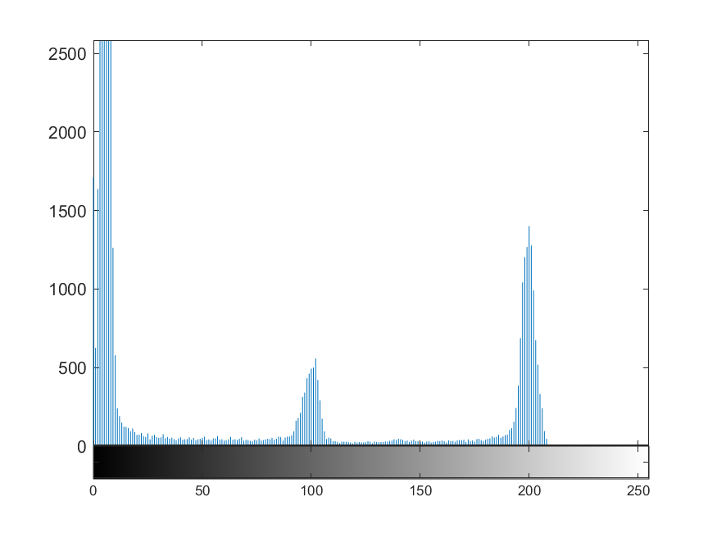

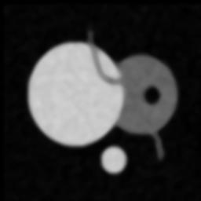

**Figure 11(a):** ATM Filtered image (iteration 5) **Figure 11(b):** Histogram (iteration 5)

Mean and Standard deviation of the largest disk after iteratively applying the mean filter is shown in Figure 12.

|  |  |  |
| --- | --- | --- |
| **Iteration** | **Mean** | **Standard Deviation** |
| **1** | **196.339931** | **17.534159** |
| **5** | **195.170791** | **19.910708** |

**Figure 12:** Tabular results of Mean and Standard Deviation of the largest disk.

**Observation:**

It can be observed that results of alpha-trimmed filter are less influenced by salt and pepper noise. Mean filter is a special case of alpha-trimmed filter for $α=0$. The edges are preserved as shown in Figures 10(a) and 11(a). Blurring effect can be observed with more iterations. This filtering method is however expensive in computation as sorting has to be performed in each iteration.

* 1. **Sigma filter**

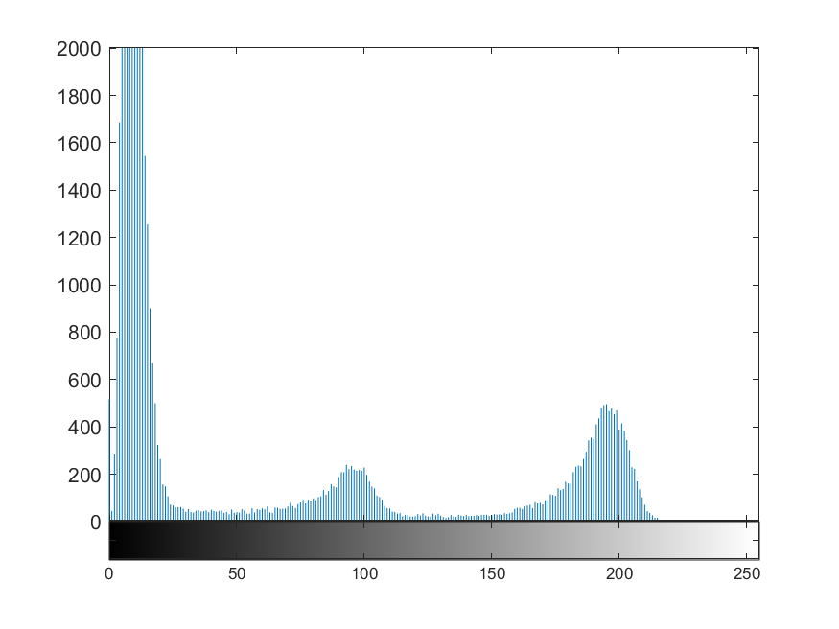A 5x5 sigma filter with $σ=20$ was applied on the image shown in Figure 1. The filter was recursively applied for 5 iterations where each pixel value was replaced with the value obtained from the sigma filter equation in Methods section using the pixels in the sliding window. Figures 13(a), 13(b) and 14(a), 14(b) show the filtered image and histogram at the end of first and fifth iterations, respectively.

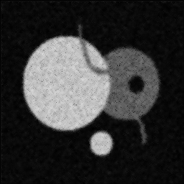

**Figure 13(a):** Sigma Filtered image (iteration 1) **Figure 13(b):** Histogram (iteration 1)

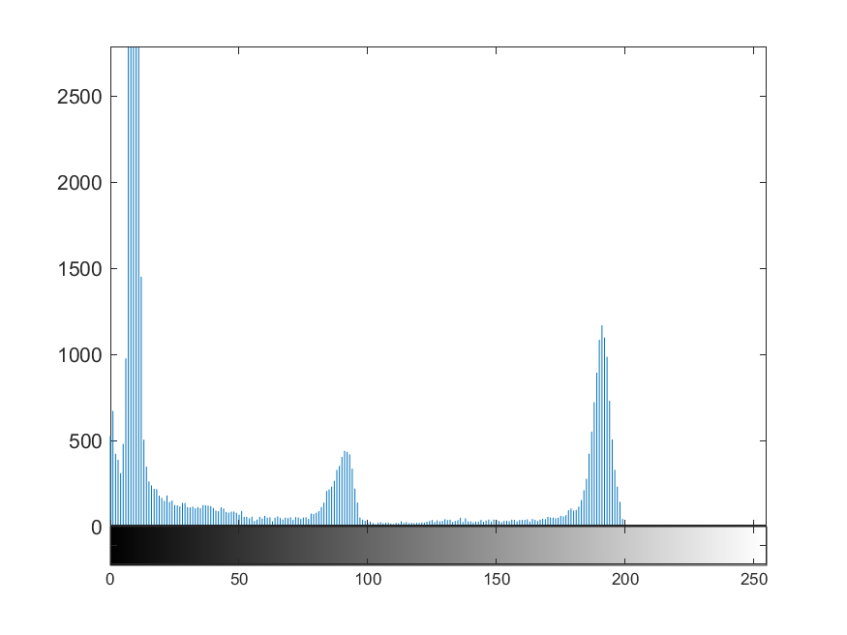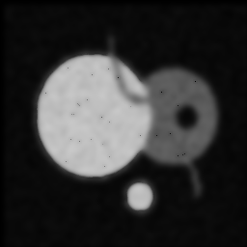

**Figure 14(a):** Sigma Filtered image (iteration 5) **Figure 14(b):** Histogram (iteration 5)

Mean and Standard deviation of the largest disk after iteratively applying the mean filter is shown in Figure 15.

|  |  |  |
| --- | --- | --- |
| **Iteration** | **Mean** | **Standard Deviation** |
| **1** | **187.509453** | **21.754606** |
| **5** | **184.032991** | **23.956818** |

**Figure 15:** Tabular results of Mean and Standard Deviation of the largest disk.

**Observation:**

The pepper noise is still evidently visible in the foreground of the image as seen in Figures 13(a) and 14(a). The higher standard deviations when compared to other types of filters indicate a loss of boundary/edges due to smoothening/blurring effect. This is further indicated in Figures 13(b) and 14(b), where the distinction between peaks 1 and 2 in the histograms are not clearly visible.

* 1. **Symmetric Nearest-Neighbor Mean filter (SNNM filter)**

A 5x5 SNNM filter was applied on the image shown in Figure 1. The filter was recursively applied for 5 iterations where each pixel value was replaced with the average value obtained from the nearest neighbor values using symmetric pixel pairs, as denoted by the equation in Methods section using the pixels in the sliding window. Figures 16(a), 16(b) and 17(a), 17(b) show the filtered image and histogram at the end of first and fifth iterations, respectively.

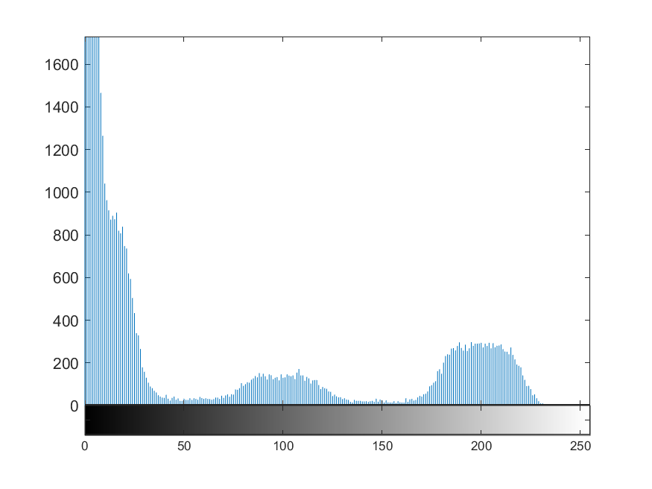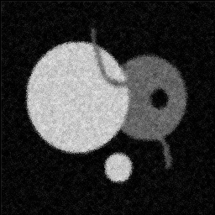

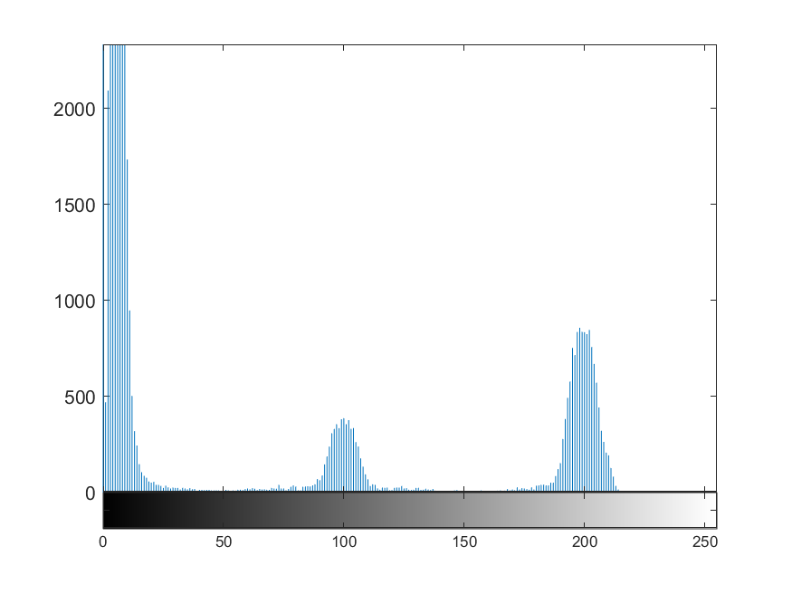**Figure 16(a):** SNNM Filtered image (iteration 1) **Figure 16(b):** Histogram (iteration 1)

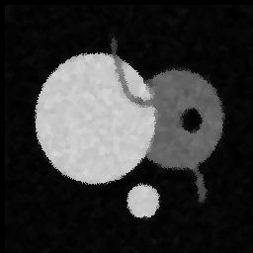

**Figure 17(a):** SNNM Filtered image (iteration 5) **Figure 17(b):** Histogram (iteration 5)

Mean and Standard deviation of the largest disk after iteratively applying the mean filter is shown in Figure 18.

|  |  |  |
| --- | --- | --- |
| **Iteration** | **Mean** | **Standard Deviation** |
| **1** | **196.464154** | **21.977833** |
| **5** | **195.663621** | **22.484127** |

**Figure 18:** Tabular results of Mean and Standard Deviation of the largest disk.

**Observation:**

This filter performs very well with clear removal of salt and pepper noise as shown in figures 16(a) and 16(b). The edges are also clearly visible. The histograms in figures 16(b) and 17(b) show an improvement in object clusters corresponding to different gray values.

**PART 2:**

**Anisotropic Diffusion for Image Filtering**

In this part of the project, we are given two different images i.e., ‘cwheelnoise.gif’ and ‘cameraman.tif’ as depicted in Figure 4 and X, respectively. Here, we apply the anisotropic diffusion algorithm depicted in L14 – P13 class notes on both the images and present the image filtering analysis with relevant figures and discussion.

In **part (a)** of this problem, we present the analysis with ‘cwheelnoise.gif’, wherein we apply the algorithm and evaluate the performance at different values of ‘k’, ‘# of iterations’ and ‘function g($∙$)’. Accordingly, we present the diffused images, histogram showing the statistical information of the image and the segmented image showing the spokes in the wheel.

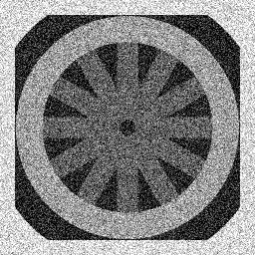 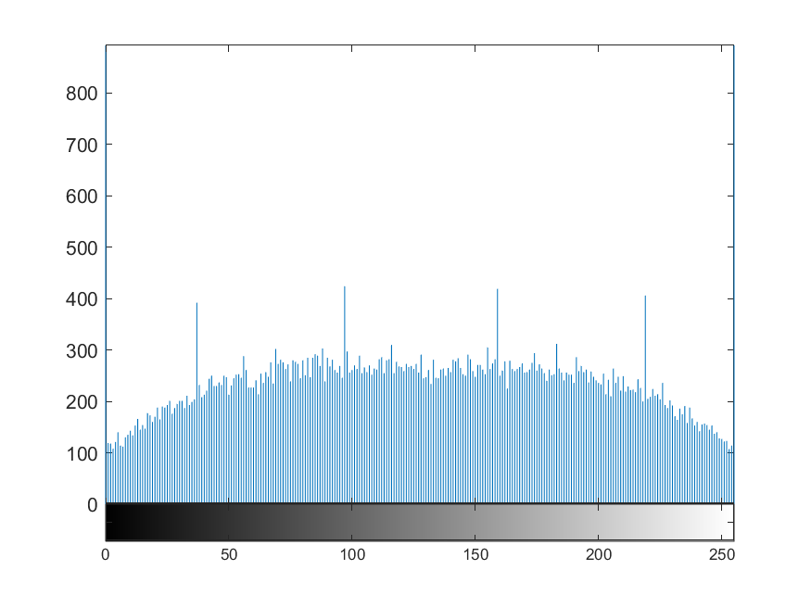

**Figure 4**: Original ‘cwheelnoise’ image and its histogram.

In Figure 4, we present the original ‘cwheelnoise’ image along with its histogram. From the figure, it can be clearly observed that the image has got a significant amount of noise which can also be observed in the histogram having several spikes i.e., almost a Gaussian distribution. However, there are 4 significant spikes which will tend to clearly distinguish when the image is smoothed & denoised, and this done by employing the anisotropic diffusion algorithm ($λ=0.25$) with following parameters:

1. Quadratic conduction coefficient
   1. k = (6, 8, 9)
2. Exponential conduction coefficient
   1. k = (20, 30, 40)

**Quadratic conduction coefficient:**

Firstly, we perform the anisotropic diffusion considering the quadratic conduction coefficient with values of ‘k’ equal to (6, 8 & 9), this aids in understanding the influence of ‘k’ on the filtering process. In addition, we run the algorithm for about 100 iterations and present the results at 0 (original), 5, 20 & 100 iterations point, to also understand the influence of number of iterations.

* We present the analysis starting with ‘**k = 6**’:

In Figure 5, we can clearly observe that the noise reduces as the number of iterations increases, i.e., as the number of iterations increases from 0 to 5, the noise is slightly reduced which can not be directly noticed. However, from the 20th to the 100th iteration, the changes are significant, i.e., the noise has reduced significantly and the image appears to be much smoother and clean.

This observation is also complemented by the histograms depicted in Figure 6. In other words, the histogram seems to be concentrated at the 4 points as the number of iterations increases which shows the reduction in noise. These 4 points/spikes can also be observed in the original histogram which become very clear as the noise reduces.

 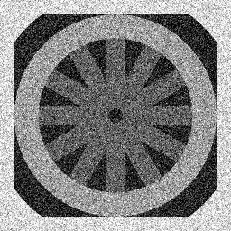

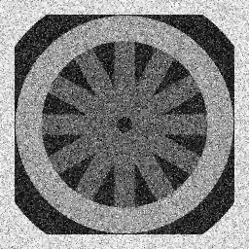 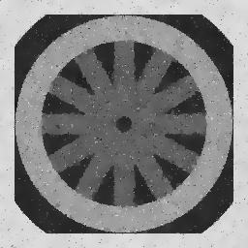

**Figure 5**: Diffused ‘cwheelnoise’ images after performing anisotropic diffusion at (0, 5, 20, 100) iterations with ‘k = 6’ and quadratic conduction coefficient.

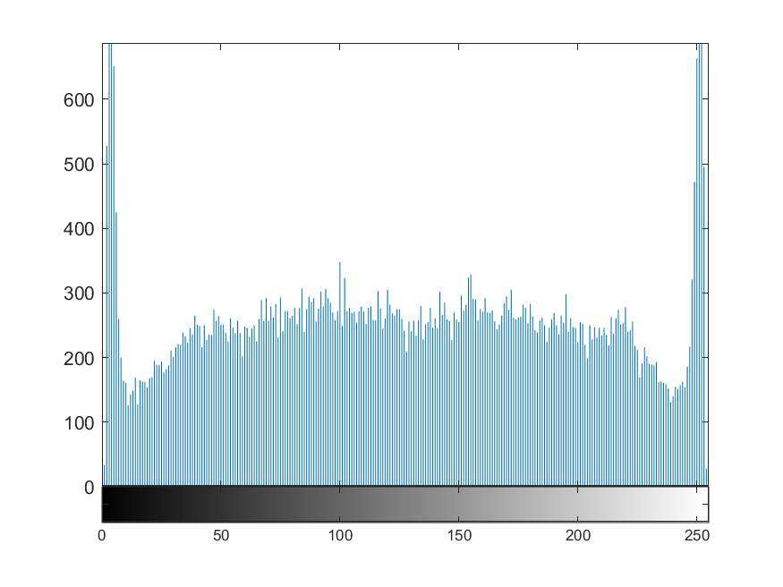

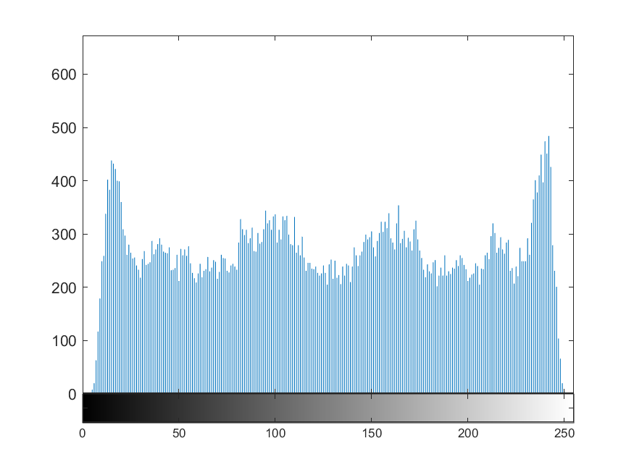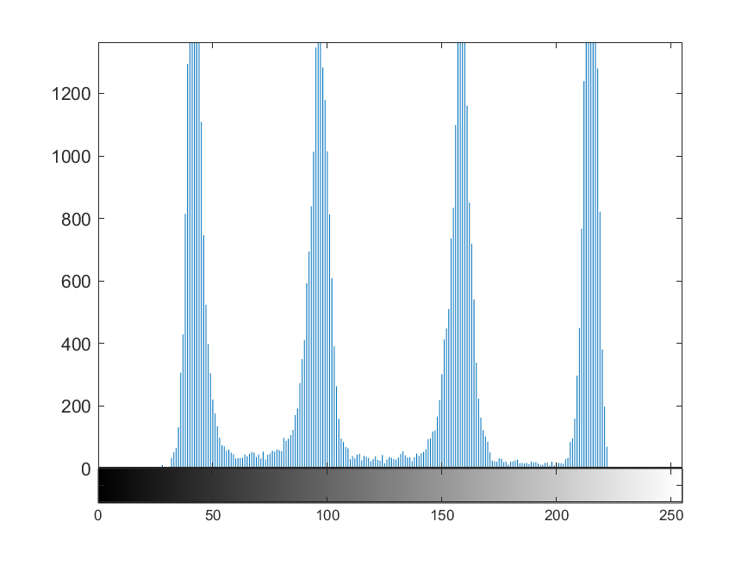

**Figure 6:** Histogram after performing anisotropic diffusion at (0, 5, 20, 100) iterations with ‘k = 6’ and quadratic conduction coefficient.

Further, we present the plot of line ‘**y = 128**’ through the image in Figure 7. In the figure, it can be observed that the line gets smoother as the noise is reduced, i.e., the spikes overall reduce in the plot. In addition, we also plot the segmented version of the diffused image, i.e., to obtain the spokes of the wheel, we threshold the image by only retaining the grayscale values ranging between 80 & 120. These thresholding values are chosen based on the spikes location in the histogram depicted in Figure 6. The segmented image is shown in Figure 8, wherein again we can observe that the spokes become clearer as the number of iterations increases and the noise is reduced.

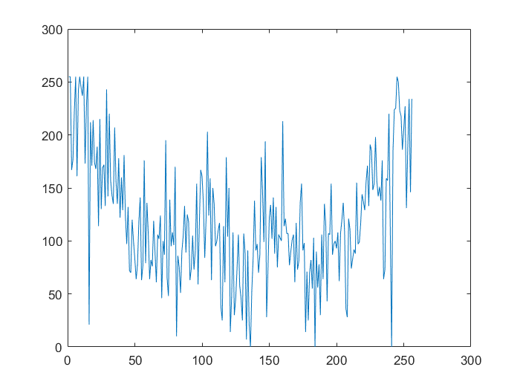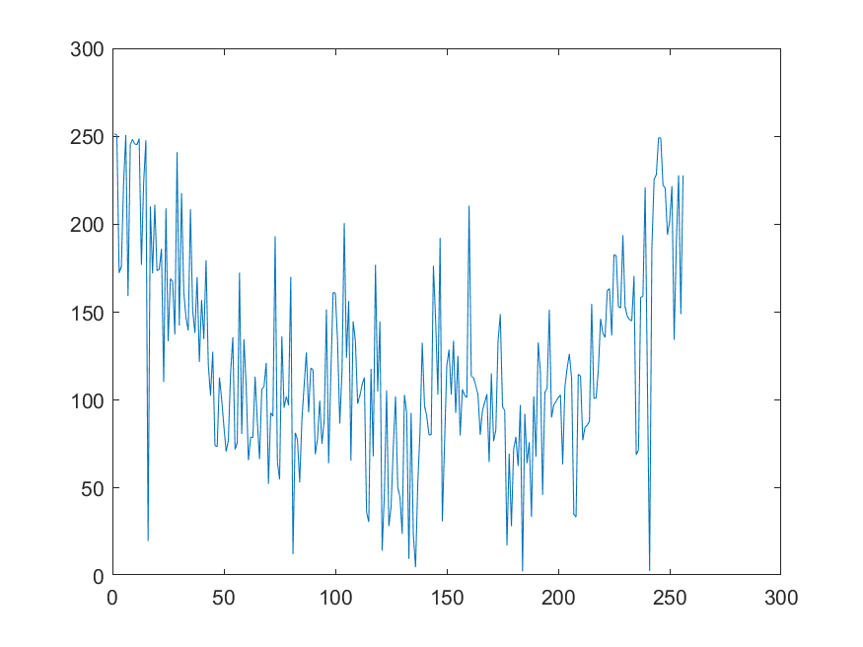

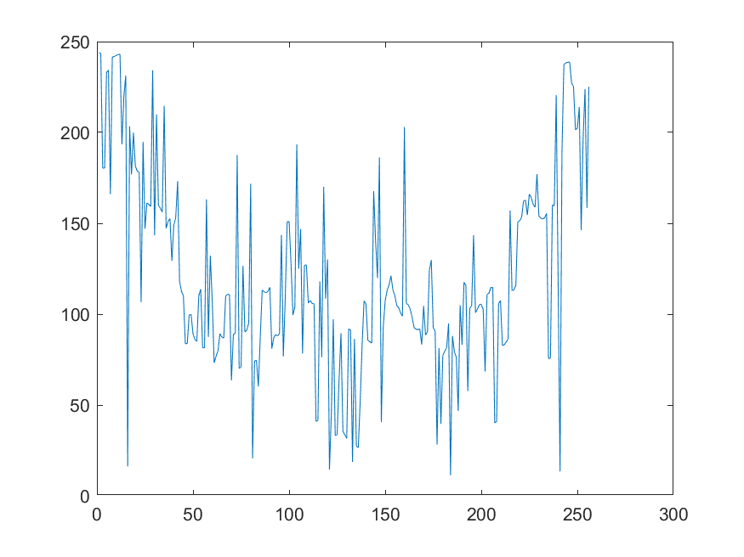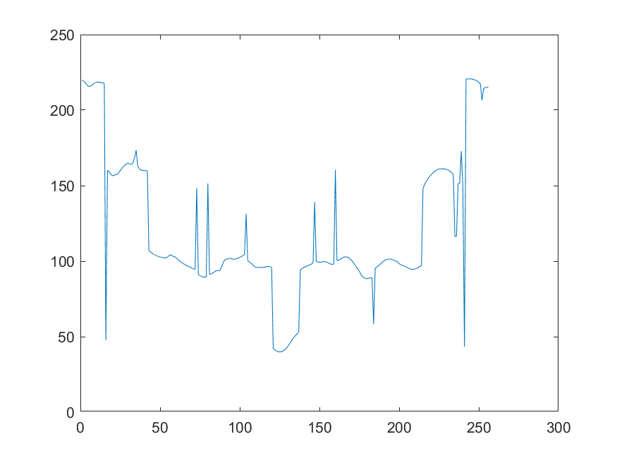

**Figure 7:** Plot of the line ‘y = 128’ through the image after performing anisotropic diffusion at (0, 5, 20, 100) iterations with ‘k = 6’ and quadratic conduction coefficient.

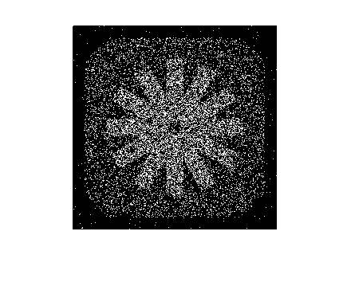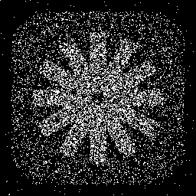

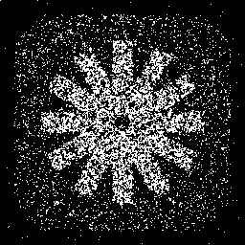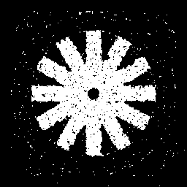

**Figure 8**: Segmented ‘cwheelnoise’ images after performing anisotropic diffusion at (0, 5, 20, 100) iterations with ‘k = 6’ and quadratic conduction coefficient.

* Next, we present the analysis for ‘**k = 8**’:

In Figure 9, we can clearly observe that the noise reduces as the number of iterations increases, i.e., from the 20th to the 100th iteration, the noise has reduced significantly and the image appears to be much smoother and clean. In addition, the noise reduction for ‘k = 8’ is significantly better than ‘k = 6’, i.e., when we compare Figure 5 & 9, it can be clearly observed that ‘k = 8’ produces much smoother and almost noise-free image. However, the drawback with ‘k = 8’ is that the edges tend to be much smoother rather than being sharper and distinguishing as produced by ‘k = 6’.

 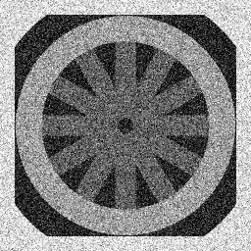

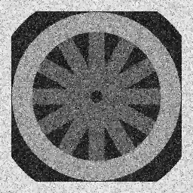 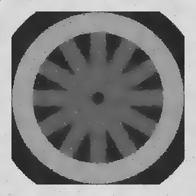

**Figure 9**: Diffused ‘cwheelnoise’ images after performing anisotropic diffusion at (0, 5, 20, 100) iterations with ‘k = 8’ and quadratic conduction coefficient.

 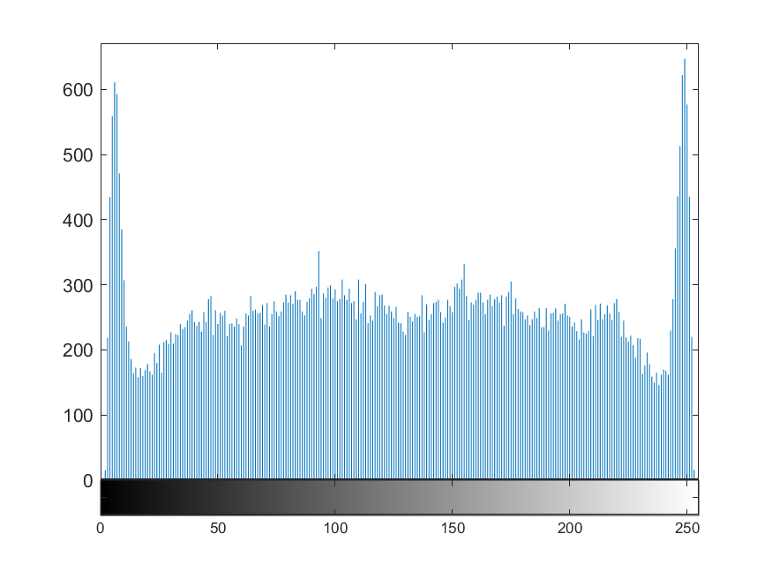

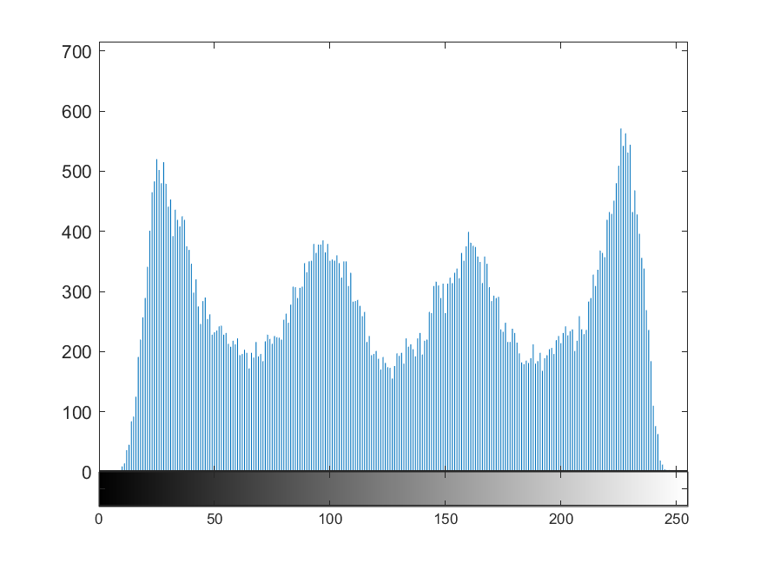 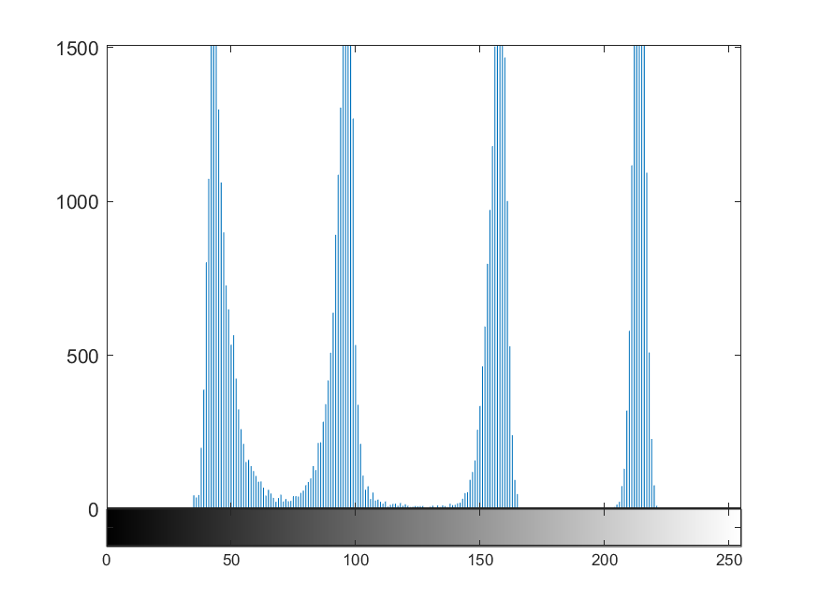

**Figure 10:** Histogram after performing anisotropic diffusion at (0, 5, 20, 100) iterations with ‘k = 8’ and quadratic conduction coefficient.

 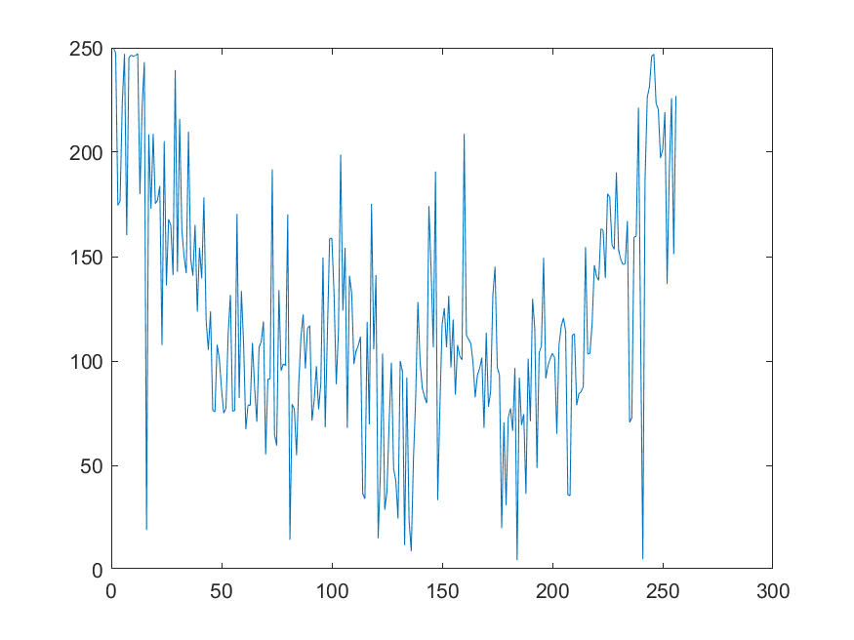

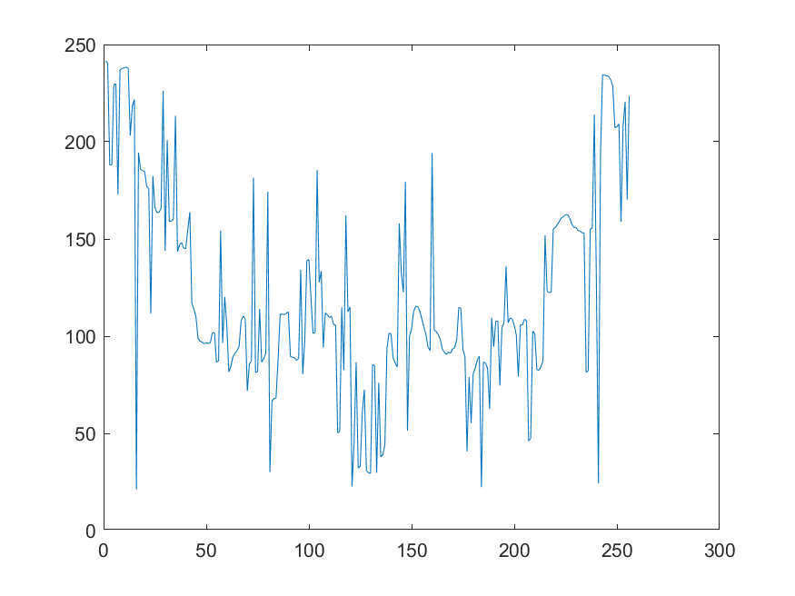 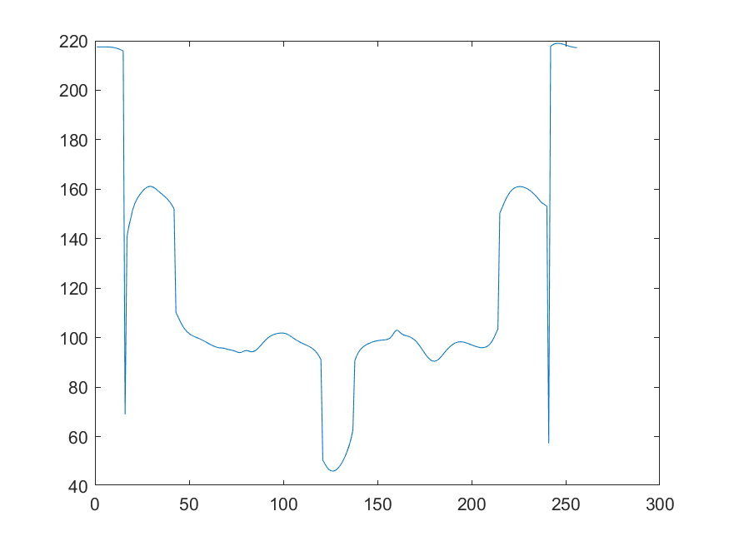

**Figure 11:** Plot of the line ‘y = 128’ through the image after performing anisotropic diffusion at (0, 5, 20, 100) iterations with ‘k = 8’ and quadratic conduction coefficient.

From the histogram and ‘y = 128’ line through the image plot depicted in Figure 10 & 11, it can be observed that the finer peaks tend to appear in the histogram and the line is much smoother with fewer peaks for the ‘y = 128’ line plot, suggesting reduction in noise for the 100th iteration.

In Figure 12, we can observe the segmented version of the diffused images for ‘k = 8’. Here, it can be observed that the spokes obtained after segmentation of the image is clear and the edges are preserved in comparison to the segmented image generated with ‘k = 6’, this shows that the value of ‘k’ plays a vital role in preserving the edges and generating a clear image. In addition, from the segmented images it can be observed that as the number of iterations increases, the image tends to diffuse more.

 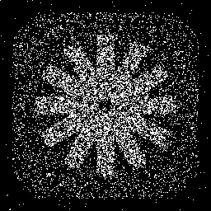

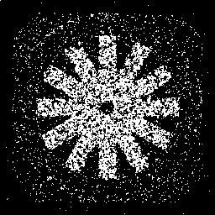 

**Figure 12**: Segmented ‘cwheelnoise’ images after performing anisotropic diffusion at (0, 5, 20, 100) iterations with ‘k = 8’ and quadratic conduction coefficient.

* Further, we present the analysis for ‘**k = 9**’:

In Figure 13, we can clearly observe that the noise reduces as the number of iterations increases, i.e., from the 20th to the 100th iteration, the noise has reduced significantly and the image appears to be much smoother and clean. However, the edges are not being preserved unlike ‘k = 6, 8’ which preserve the edges although they do not reduce the noise as extensive as ‘k = 9’ does. Hence, the image appears to be blurred as the number of iterations increases.

 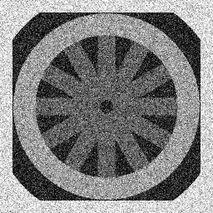

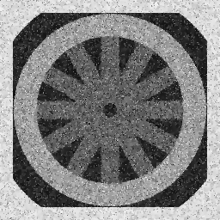 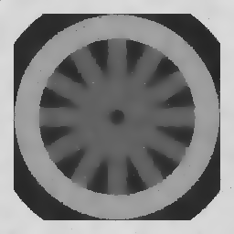

**Figure 13**: Diffused ‘cwheelnoise’ images after performing anisotropic diffusion at (0, 5, 20, 100) iterations with ‘k = 9’ and quadratic conduction coefficient.

From the histogram and ‘y = 128’ line through the image plot depicted in Figure 14 & 15, it can be observed that the finer peaks with valley indicate the loss of edges in the diffused image. In addition, the ‘y = 128’ line shows that the plot is very symmetrical and noise free with a smooth nature.

 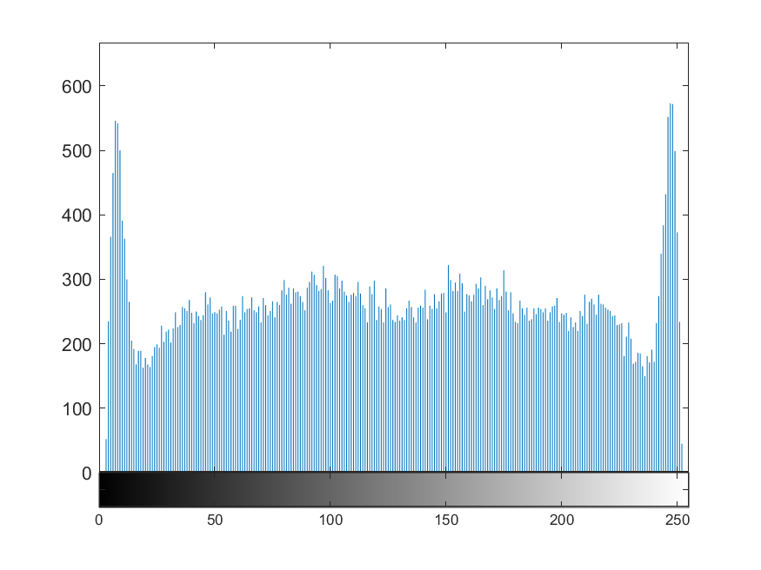

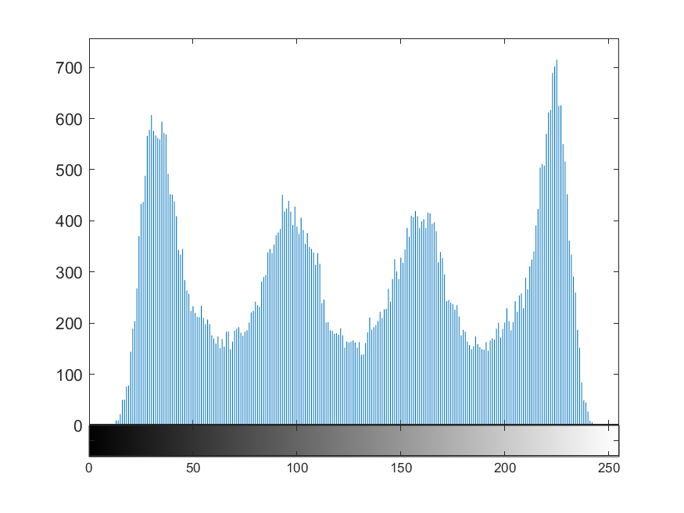 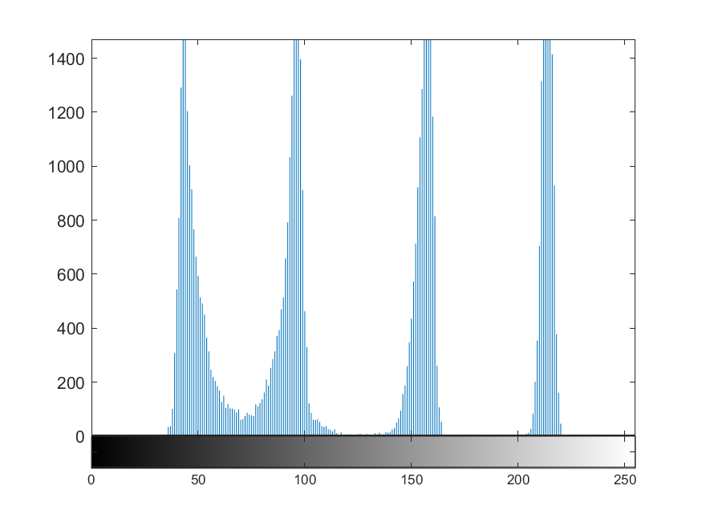

**Figure 14:** Histogram after performing anisotropic diffusion at (0, 5, 20, 100) iterations with ‘k = 9’ and quadratic conduction coefficient.

 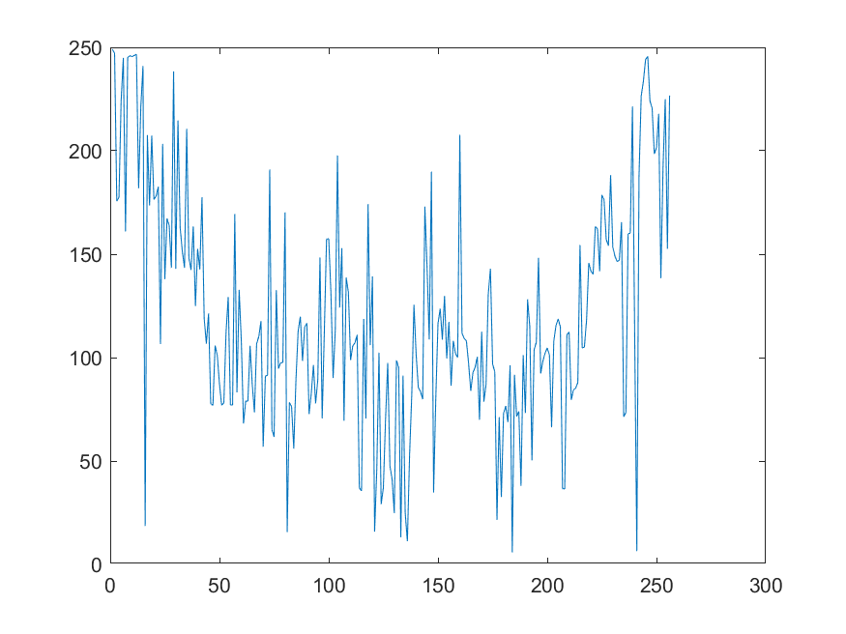

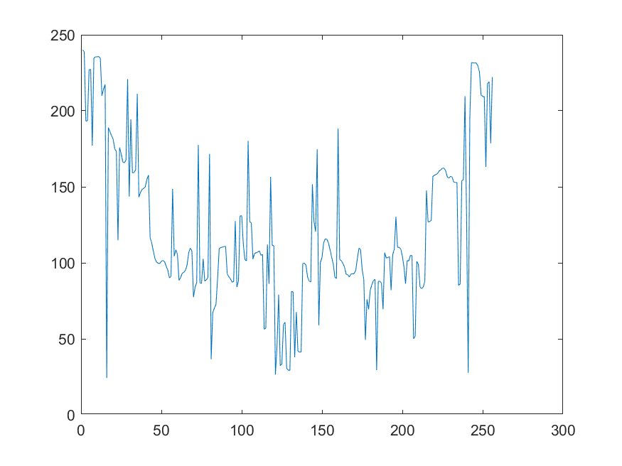 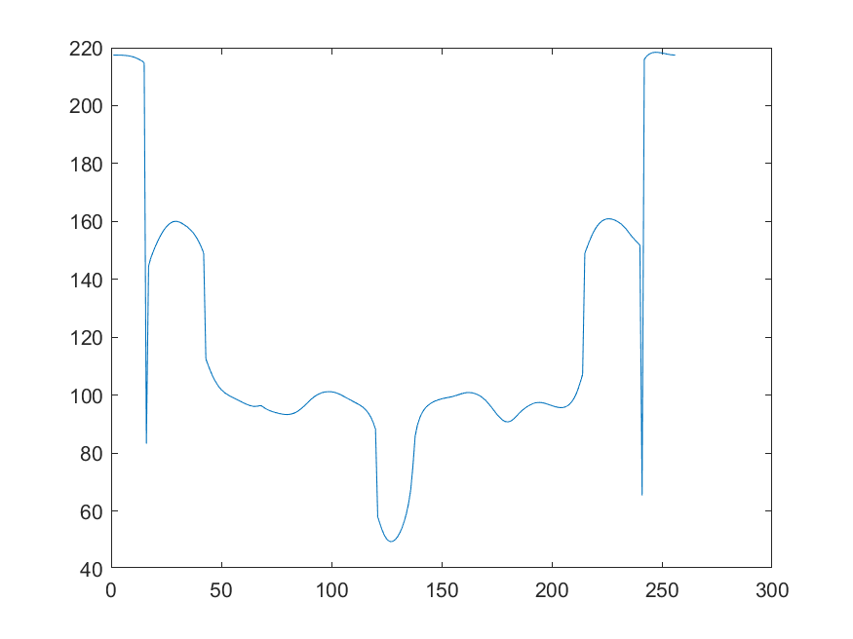

**Figure 15:** Plot of the line ‘y = 128’ through the image after performing anisotropic diffusion at (0, 5, 20, 100) iterations with ‘k = 8’ and quadratic conduction coefficient.

In Figure 16, we can observe the segmented version of the diffused images for ‘k = 9’. Here, it can be observed that the spokes obtained after segmentation of the image is clear, but the edges appear to be rough and not preserved unlike the segmented image generated with ‘k = 8’ which preserves the edges, this shows that the value of ‘k’ plays a vital role in preserving the edges and generating a clear image. In addition, from the segmented images it can be observed that as the number of iterations increases, the image tends to diffuse more.

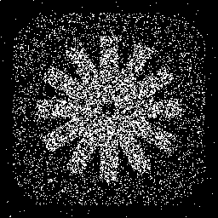

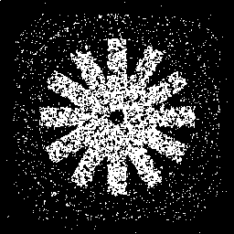

**Figure 16**: Segmented ‘cwheelnoise’ images after performing anisotropic diffusion at (0, 5, 20, 100) iterations with ‘k = 8’ and quadratic conduction coefficient.

**Exponential conduction coefficient:**

Firstly, we perform the anisotropic diffusion considering the exponential conduction coefficient with values of ‘k’ equal to (20, 30 & 40), this aids in understanding the influence of ‘k’ on the filtering process. In addition, we run the algorithm for about 100 iterations and present the results at 0 (original), 5, 20 & 100 iterations point, to also understand the influence of number of iterations.

* We present the analysis starting with ‘**k = 20**’:

In Figure 17, we can clearly observe that the noise reduces as the number of iterations increases, i.e., from the 20th to the 100th iteration, the noise has reduced significantly and the image appears to be much smoother and clean. However, the denoising using the exponential conduction coefficient is not as effective as the one obtained using quadratic conduction coefficient (Figure 5, 9 & 13), this suggests the importance behind choosing the right conduction coefficient as per the image.

 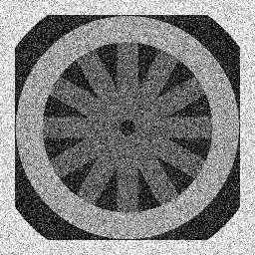

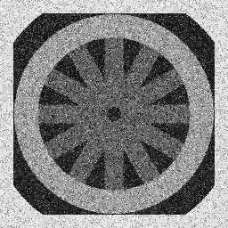 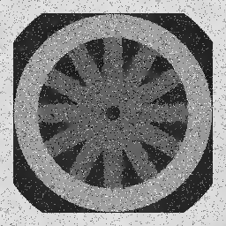

**Figure 17**: Diffused ‘cwheelnoise’ images after performing anisotropic diffusion at (0, 5, 20, 100) iterations with ‘k = 20’ and exponential conduction coefficient.

The histogram depicted in Figure 18, shows broader and separate peaks. However, the edges are not preserved and valleys are formed in the histogram. The ‘y = 128’ line through the image plot depicted in Figure 19, shows that the plot is not symmetric and the image quality is affected or deteriorated.

 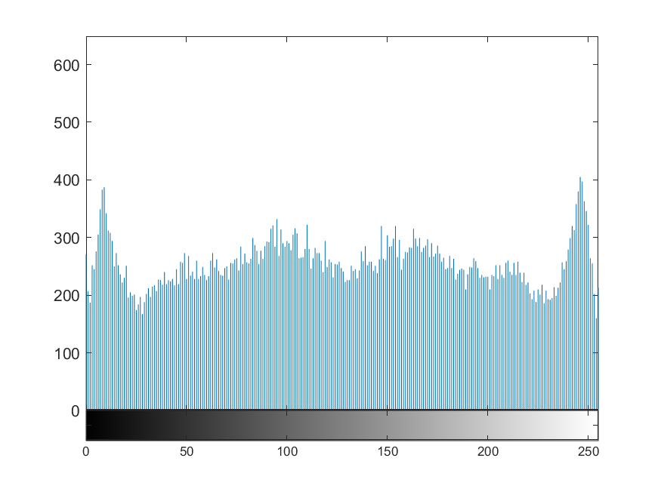

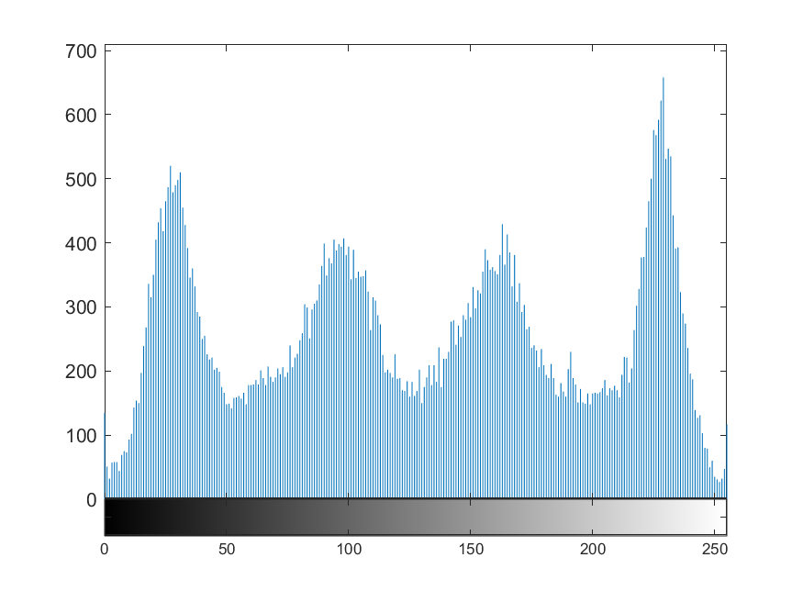 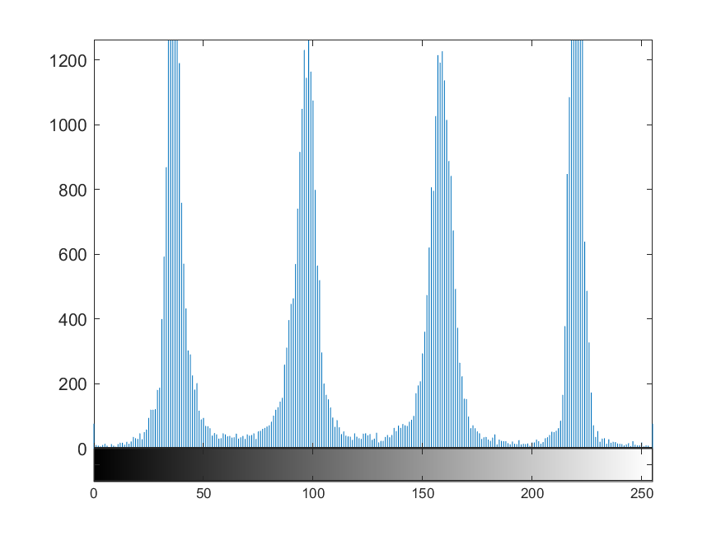

**Figure 18:** Histogram after performing anisotropic diffusion at (0, 5, 20, 100) iterations with ‘k = 20’ and exponential conduction coefficient.

 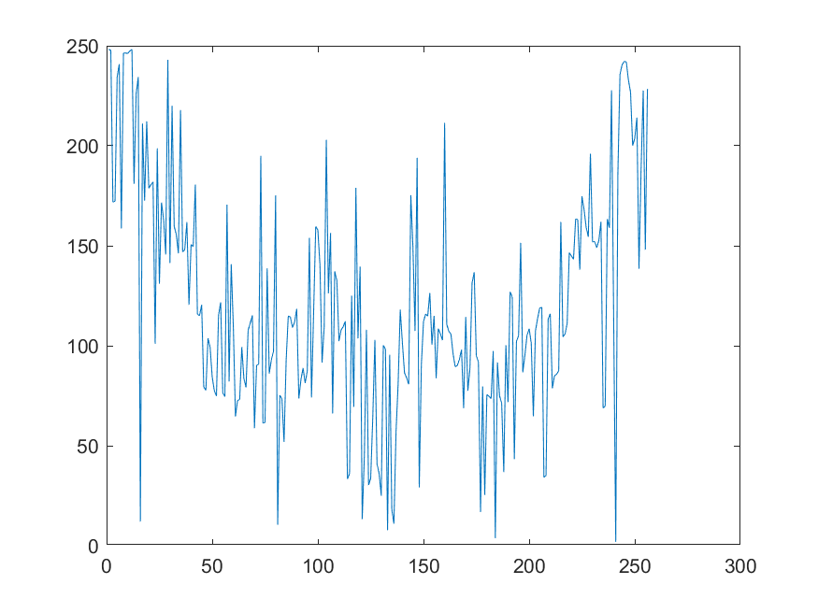

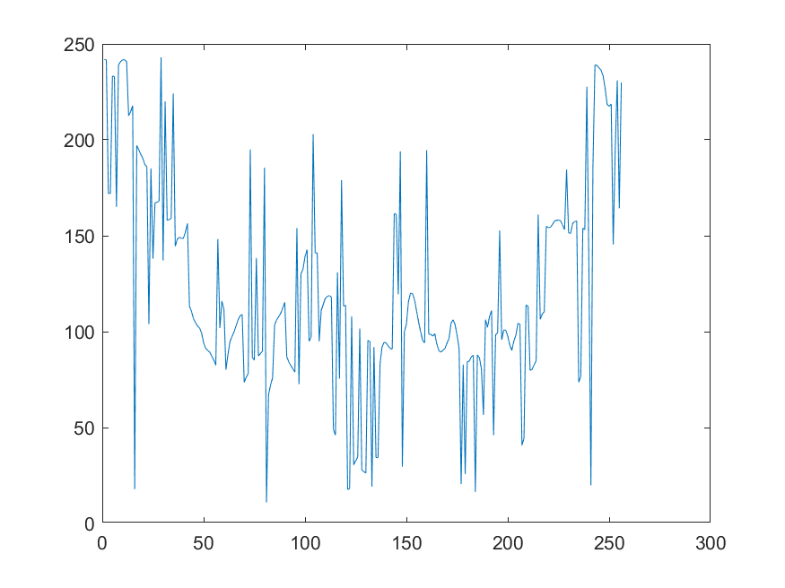 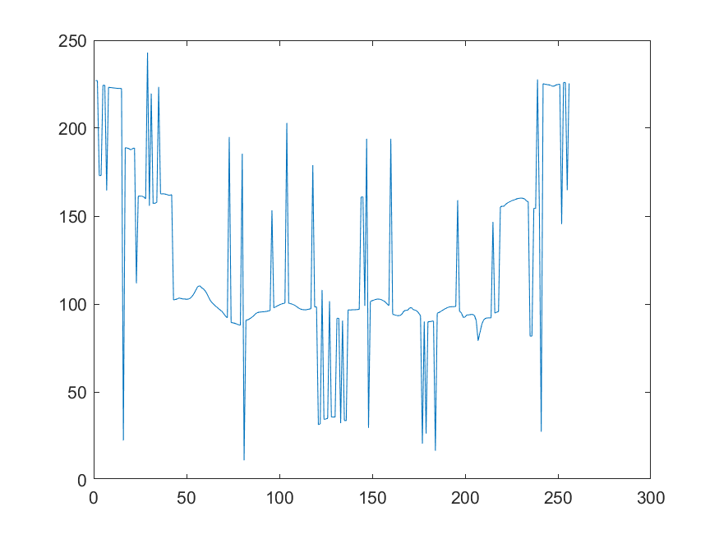

**Figure 19:** Plot of the line ‘y = 128’ through the image after performing anisotropic diffusion at (0, 5, 20, 100) iterations with ‘k = 20’ and exponential conduction coefficient.

 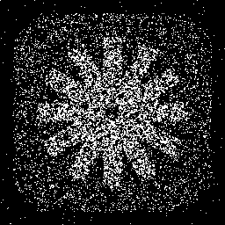

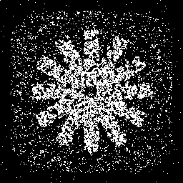 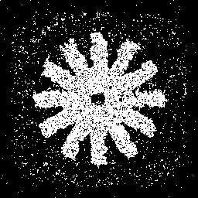

**Figure 20**: Segmented ‘cwheelnoise’ images after performing anisotropic diffusion at (0, 5, 20, 100) iterations with ‘k = 20’ and exponential conduction coefficient.

In Figure 20, we can observe the segmented version of the diffused images for ‘k = 20’ with exponential conduction coefficient. Here, it can be observed that the spokes obtained after segmentation of the image are very noisy and not clear. In addition, the edges are also not clear.

* Next, we present the analysis starting with ‘**k = 30**’:

In Figure 21, we can clearly observe that the noise reduces at the cost of blurring the image as the number of iterations increases, i.e., from the 20th to the 100th iteration. The diffused image at the 100th image is very smooth with the edges not preserved. Another interesting observation made from this result is that for the exponential conduction coefficient, the rate of reduction of noise as the number of iterations grows is higher than with the quadratic conduction coefficient.

 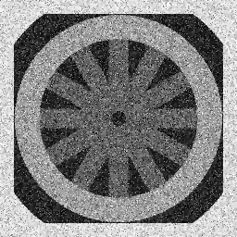

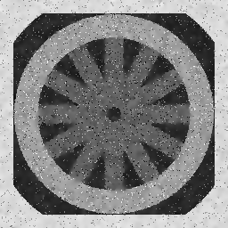 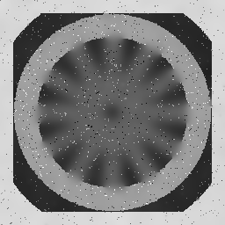

**Figure 21**: Diffused ‘cwheelnoise’ images after performing anisotropic diffusion at (0, 5, 20, 100) iterations with ‘k = 30’ and exponential conduction coefficient.

The histogram depicted in Figure 22 also shows broader and separate peaks similar to one observed in Figure 18. Similarly, the ‘y = 128’ line through the image plot depicted in Figure 23, shows that the plot is not symmetric and the image quality is affected or deteriorated.

 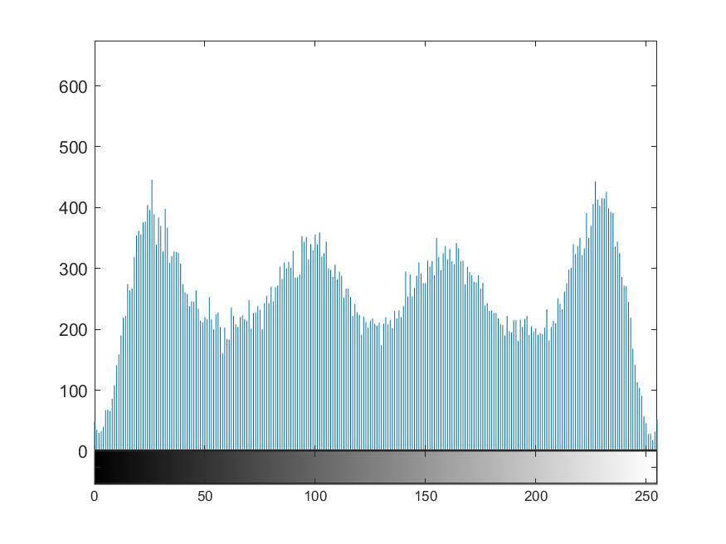

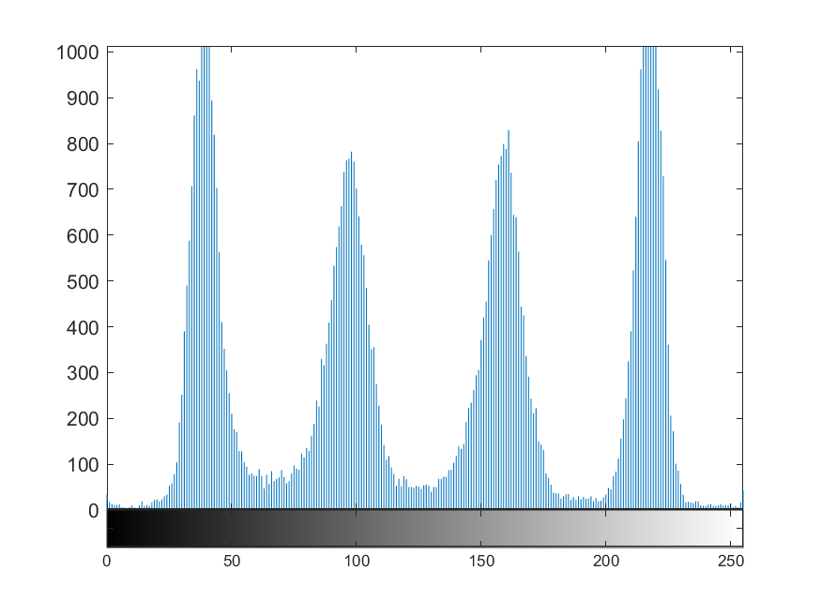 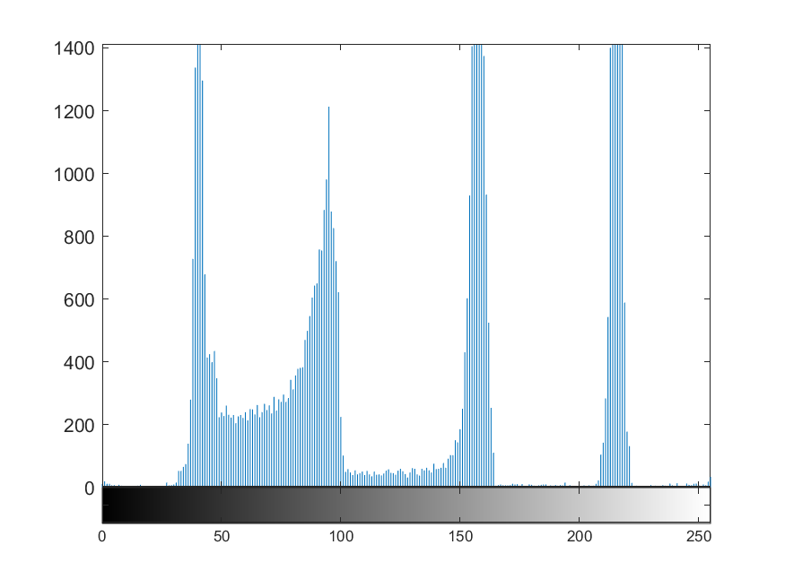

**Figure 22:** Histogram after performing anisotropic diffusion at (0, 5, 20, 100) iterations with ‘k = 30’ and exponential conduction coefficient.

 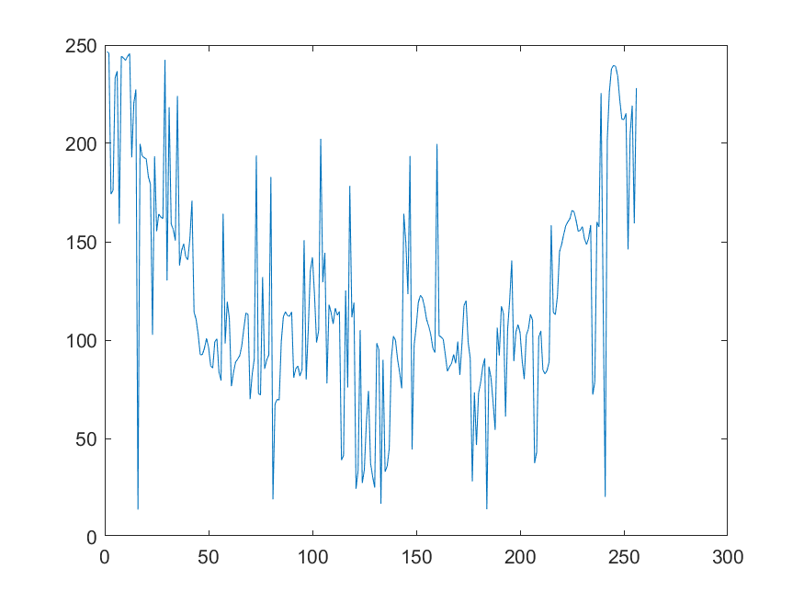

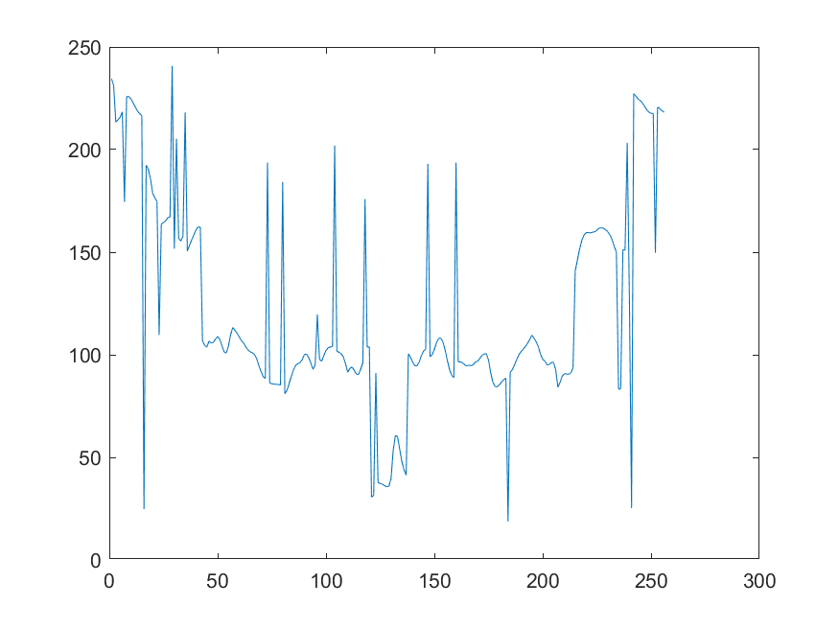 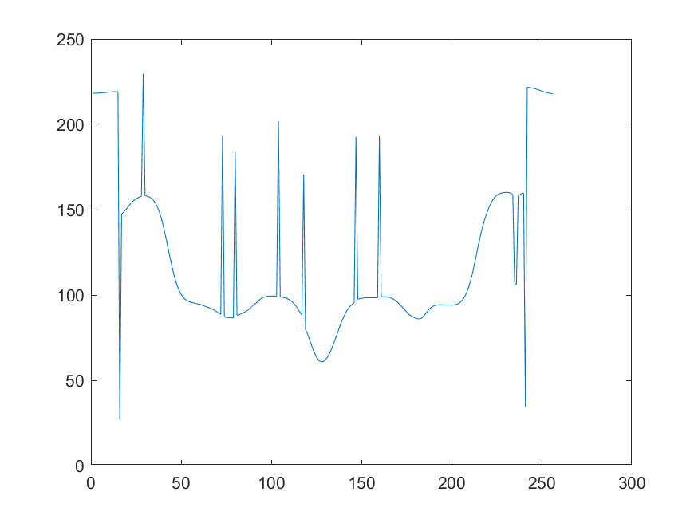

**Figure 23:** Plot of the line ‘y = 128’ through the image after performing anisotropic diffusion at (0, 5, 20, 100) iterations with ‘k = 30’ and exponential conduction coefficient.

 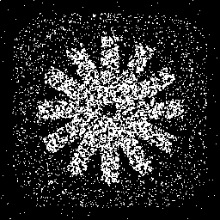

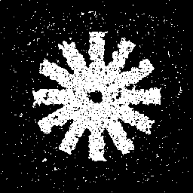 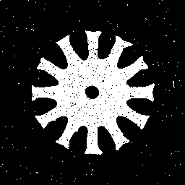

**Figure 24**: Segmented ‘cwheelnoise’ images after performing anisotropic diffusion at (0, 5, 20, 100) iterations with ‘k = 30’ and exponential conduction coefficient.

In Figure 24, we can observe the segmented version of the diffused images for ‘k = 30’ with exponential conduction coefficient. Here, it can be observed that the spokes obtained after segmentation of the image are very noisy and not clear. In addition, the edges are also not clear.

* Further, we present the analysis starting with ‘**k = 40**’:

In Figure 25, we can clearly observe that the noise reduces at the cost of blurring the image as the number of iterations increases, i.e., from the 20th to the 100th iteration. However, the image is very blurred and the some amount of noise still remains after 100th iteration unlike the quadratic, where noise is completely eliminated. Another interesting observation made from this result is that the rate of blurring increases with increase in the value of ‘k’ for exponential conduction coefficient.

 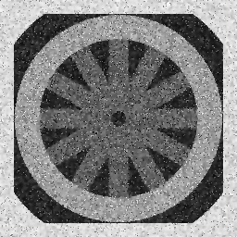

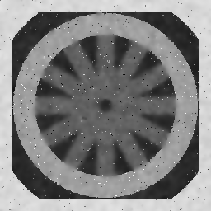 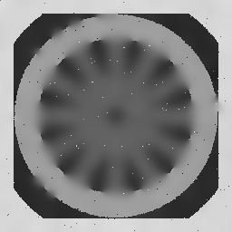

**Figure 25**: Diffused ‘cwheelnoise’ images after performing anisotropic diffusion at (0, 5, 20, 100) iterations with ‘k = 40’ and exponential conduction coefficient.

The histogram depicted in Figure 26 also shows broader and separate peaks similar to one observed in Figure 18 & 22. Similarly, the ‘y = 128’ line through the image plot depicted in Figure 27, shows that the plot is not symmetric and the image quality is affected or deteriorated.

 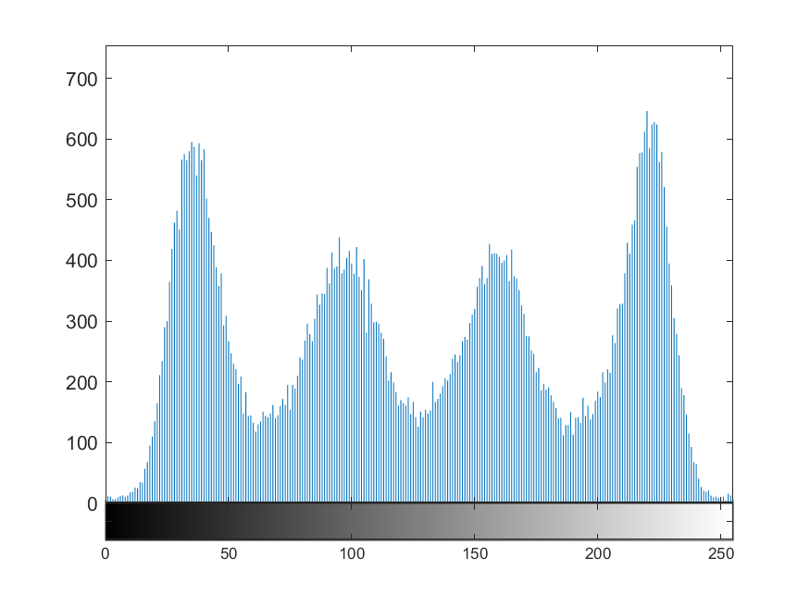

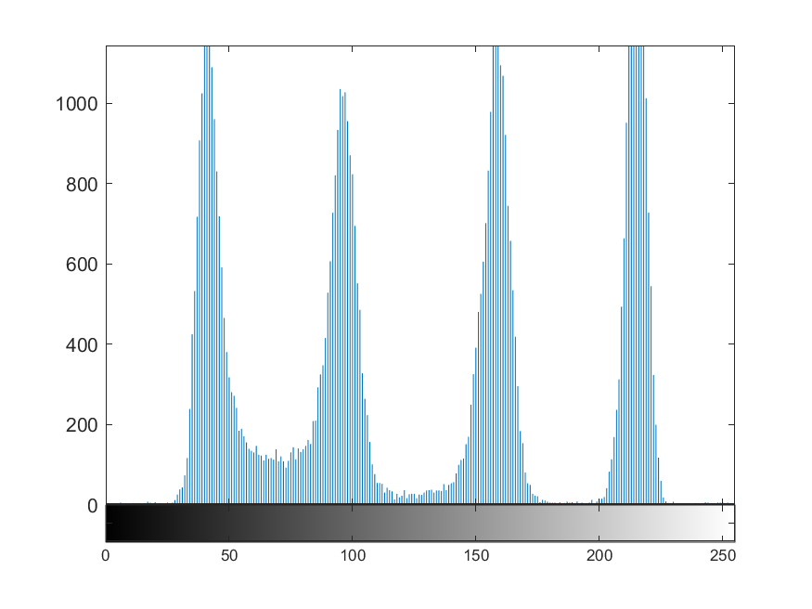 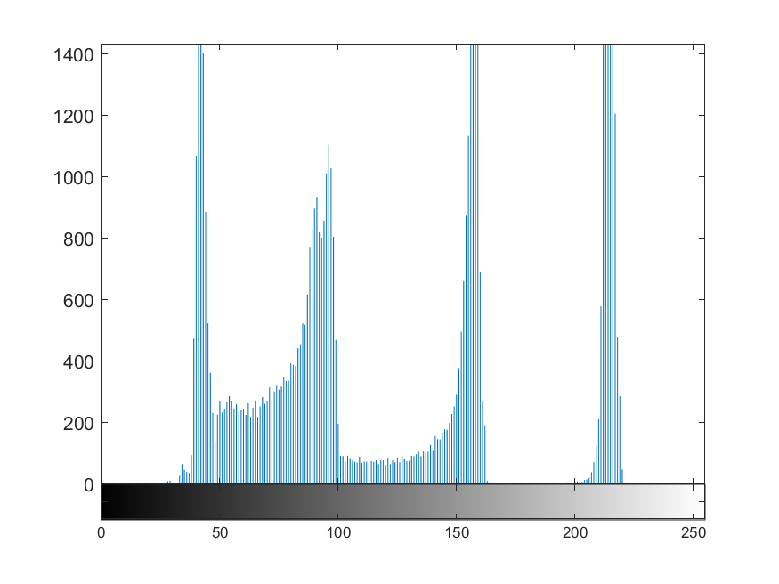

**Figure 26:** Histogram after performing anisotropic diffusion at (0, 5, 20, 100) iterations with ‘k = 40’ and exponential conduction coefficient.

 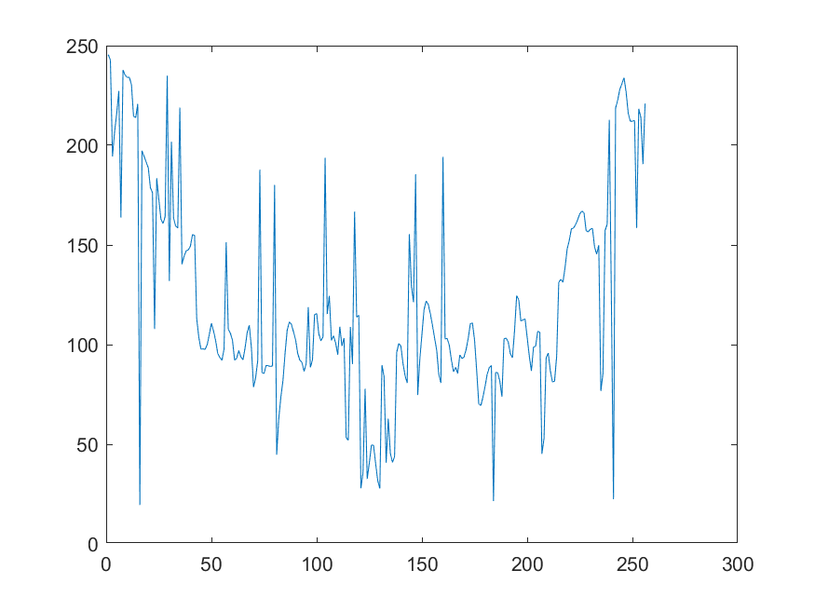

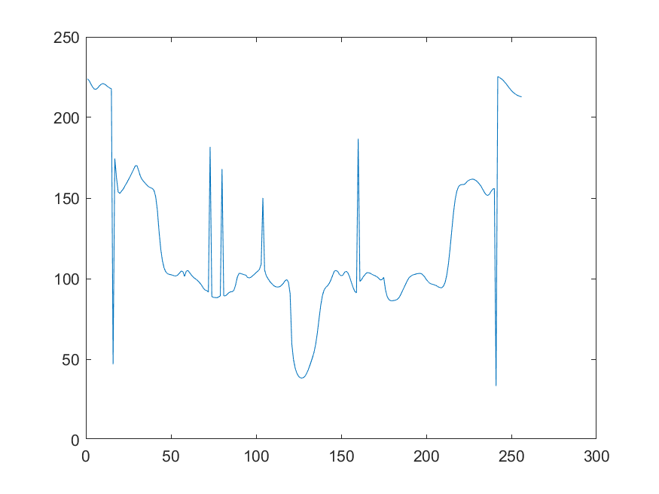 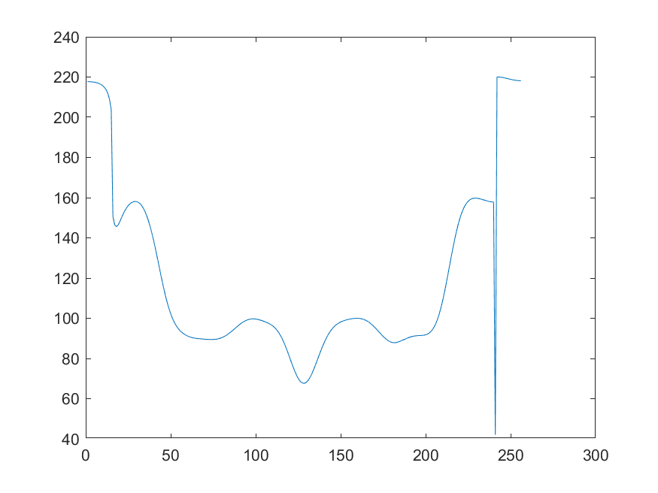

**Figure 27:** Plot of the line ‘y = 128’ through the image after performing anisotropic diffusion at (0, 5, 20, 100) iterations with ‘k = 40’ and exponential conduction coefficient.

 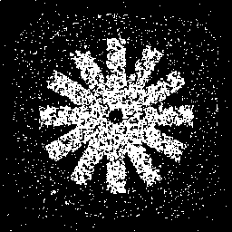

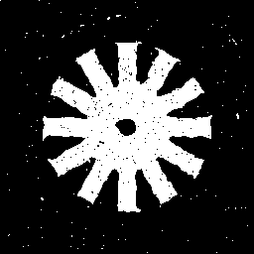 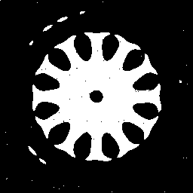

**Figure 28**: Segmented ‘cwheelnoise’ images after performing anisotropic diffusion at (0, 5, 20, 100) iterations with ‘k = 40’ and exponential conduction coefficient.

In Figure 28, it is clearly evident that the edges are lost with the image being blurred and the noise still remains after 100 iteration with increase in ‘k’ value as well with quadratic conduction coefficient. This clearly suggests that with increase in ‘k’ similar results can be expected and if we reduce the value of ‘k’ then the noise will not reduce in the image. Therefore, among inverse quadratic and exponential conduction coefficient for image denoising with different values, **inverse quadratic performs the best with the ‘k’ value being 8** as observed in Figure 9, 10, 11 & 12.

Next, in **part (b)** of this problem, we present the analysis with ‘cameraman.tif’, wherein we apply the algorithm and evaluate the performance at different values of ‘k’, ‘# of iterations’ and ‘function g($∙$)’.



**Figure 29**: Original ‘cameraman’ image.

In Figure 29, we present the original ‘cameraman’ image and we perform the analysis considering the anisotropic diffusion algorithm ($λ=0.25$) with the following parameters:

1. Quadratic conduction coefficient
   1. k = (6, 8, 9)
2. Exponential conduction coefficient
   1. k = (20, 30, 40)

**Quadratic conduction coefficient:**

Firstly, we perform the anisotropic diffusion considering the exponential conduction coefficient with values of ‘k’ equal to (6, 8 & 9), this aids in understanding the influence of ‘k’ on the filtering process. In addition, we run the algorithm for about 100 iterations and present the results at 0 (original), 5, 20 & 100 iterations point, to also understand the influence of number of iterations.

* We present the analysis starting with ‘**k = 6**’:

 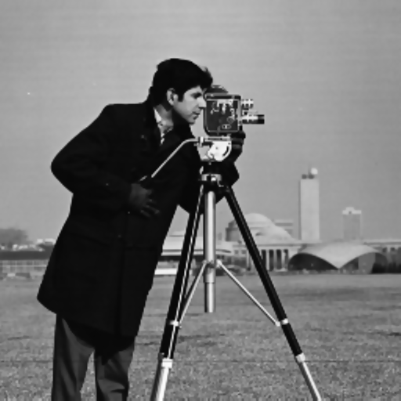

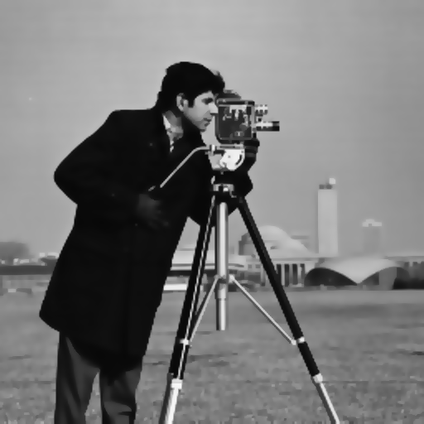 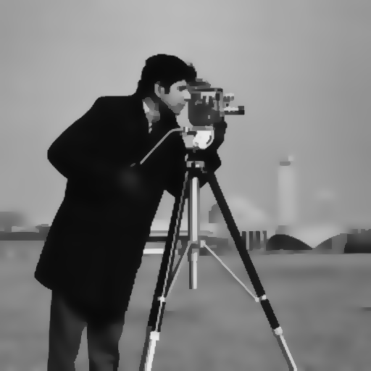

**Figure 30**: Diffused ‘cameraman’ images after performing anisotropic diffusion at (0, 5, 20, 100) iterations with ‘k = 6’ and quadratic conduction coefficient.

In Figure 30, we can observe that as the number of iterations increases with the quadratic conduction coefficient the image tends to get finer with more details. However, the image also starts to appear blurred and not preserve the edges.

* Next, we present the analysis starting with ‘**k = 8**’:

 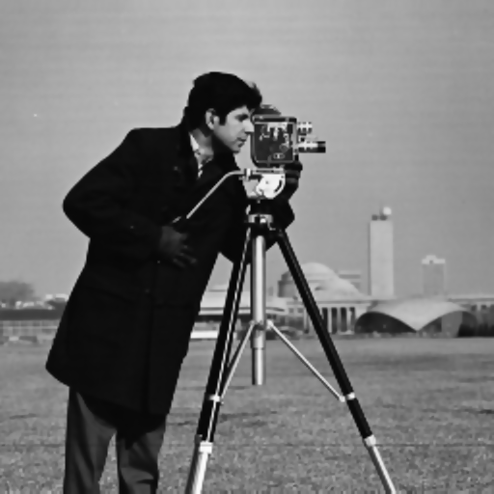

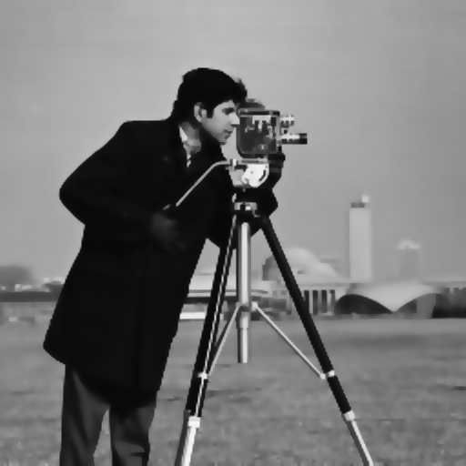 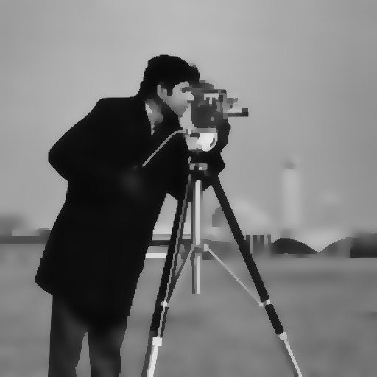

**Figure 31**: Diffused ‘cameraman’ images after performing anisotropic diffusion at (0, 5, 20, 100) iterations with ‘k = 8’ and quadratic conduction coefficient.

In Figure 31, we can observe that the image tends to get finer with more details in comparison with the images generated using ‘k = 8’, which shows that the increase in value of ‘k’ is making the image finer. However, the image also starts to appear further blurred and not preserve the edges when the value of ‘k’ increases.

* Further, we present the analysis starting with ‘**k = 9**’:

 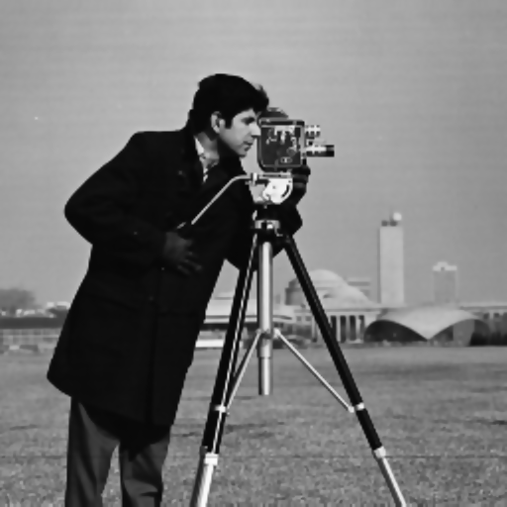

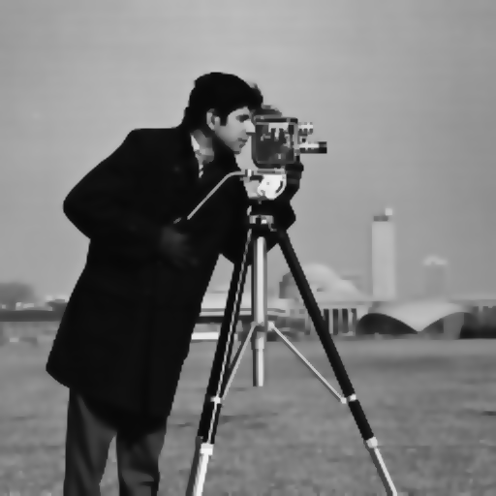 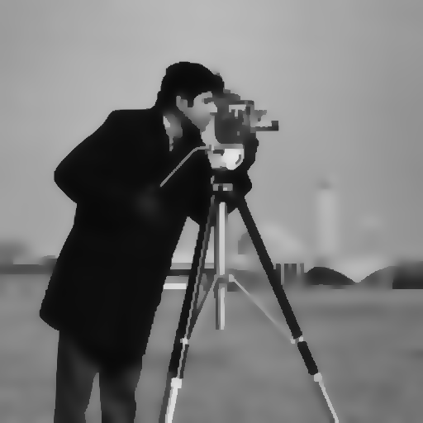

**Figure 32**: Diffused ‘cameraman’ images after performing anisotropic diffusion at (0, 5, 20, 100) iterations with ‘k = 9’ and quadratic conduction coefficient.

In Figure 32, we can observe similar trend as observed in Figure 31, i.e., as the ‘k’ value starts to increase the image gets finer but also starts to get smoother. Thus, for the quadratic conduction coefficient, as the value of ‘k’ increases, the image gets smoother because the coefficient is built in such a way that it focusses more towards the larger regions than the smaller regions. Further, in the similar lines, we evaluate the ‘cameraman’ image with the exponential conduction coefficient with different values of ‘k’ and present the analysis.

**Exponential conduction coefficient:**

Firstly, we perform the anisotropic diffusion considering the exponential conduction coefficient with values of ‘k’ equal to (20, 30 & 40), this aids in understanding the influence of ‘k’ on the filtering process. In addition, we run the algorithm for about 100 iterations and present the results at 0 (original), 5, 20 & 100 iterations point, to also understand the influence of number of iterations.

* We present the analysis starting with ‘**k = 20**’:

 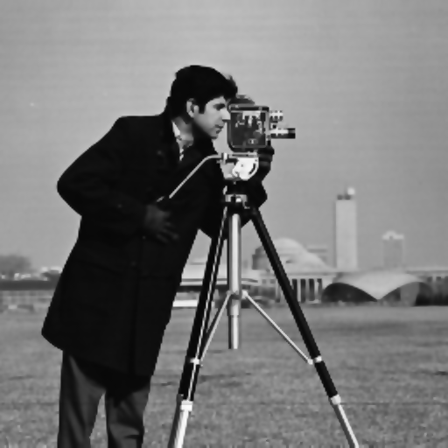

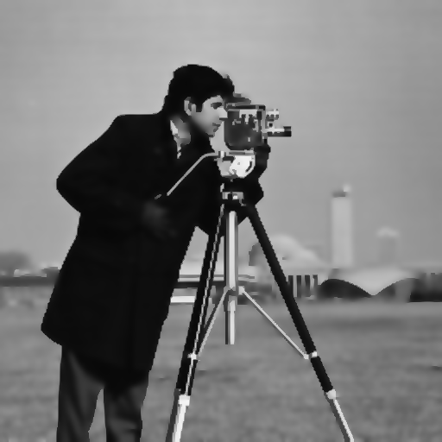 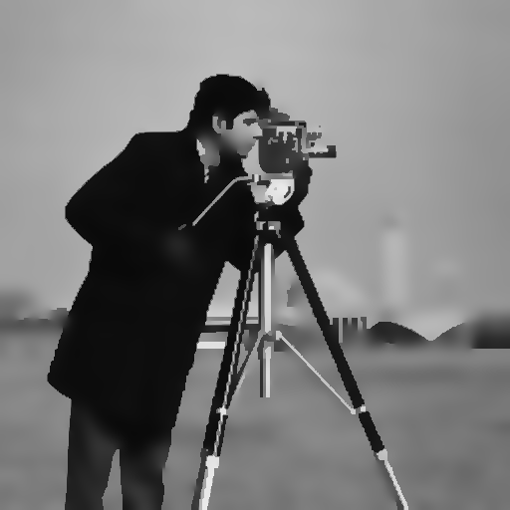

**Figure 33**: Diffused ‘cameraman’ images after performing anisotropic diffusion at (0, 5, 20, 100) iterations with ‘k = 20’ and quadratic conduction coefficient.

In Figure 33, we can observe that as the number of iterations increases with the exponential conduction coefficient the image tends to get finer with more details. In addition, the subject tends be sharper and the background is more blurred in the case of exponential conduction coefficient as compared to the one generated by quadratic conduction coefficient.

* Next, we present the analysis starting with ‘**k = 30**’:

 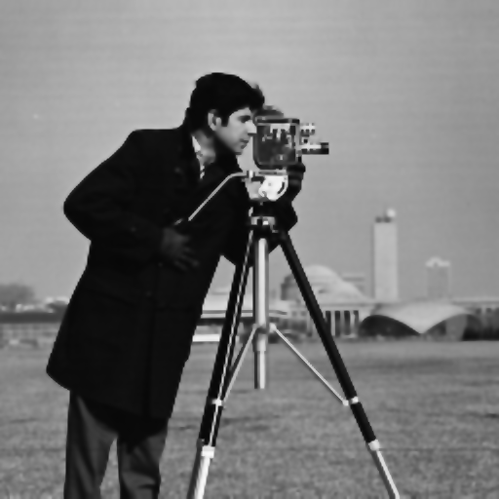

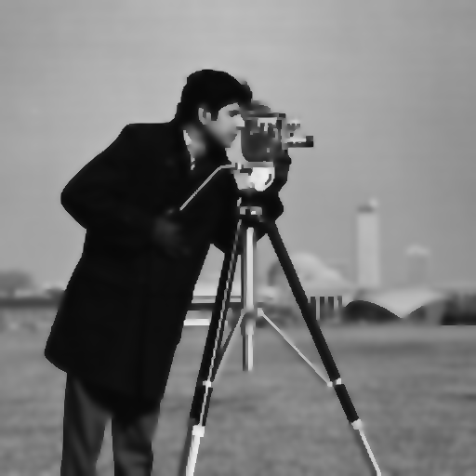 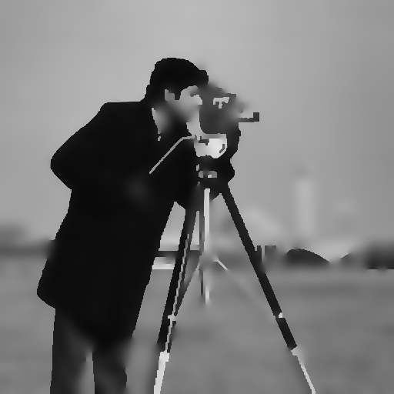

**Figure 34**: Diffused ‘cameraman’ images after performing anisotropic diffusion at (0, 5, 20, 100) iterations with ‘k = 30’ and quadratic conduction coefficient.

In Figure 34, for ‘k = 30’ we observe similar pattern as observed for ‘k = 20’, i.e., the anisotropic diffused image tends to be smoother and finer with distinguishing edges. Since, the image was not noisy originally, thus, the results by the anisotropic diffusion are better on the ‘cameraman’ than the ‘cwheelnoise’ image.

* Further, we present the analysis starting with ‘**k =40**’:

 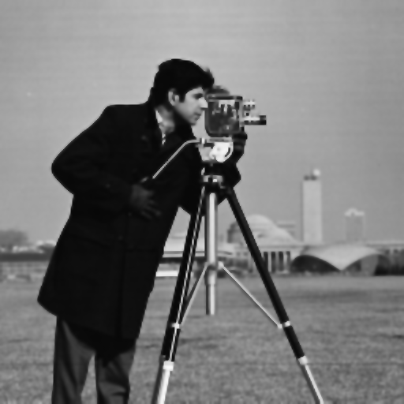

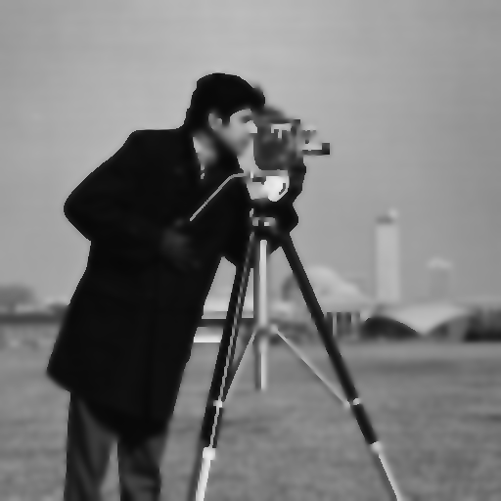 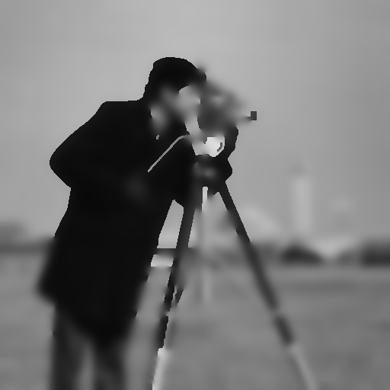

**Figure 35**: Diffused ‘cameraman’ images after performing anisotropic diffusion at (0, 5, 20, 100) iterations with ‘k = 40’ and quadratic conduction coefficient.

In Figure 35, diffused images generated after performing anisotropic diffusion with ‘k = 40’ can be observed. Here, the image after 100 iterations is completely blurred with no discrimination between the edges and the background. The performance is comparatively poor for ‘k = 40’ and the value of ‘k’ can be restricted to 20 in order to get an optimal output. Therefore, we conclude that ‘k = 30’ at 5th iteration (Figure 34) is the best output for the ‘cameraman’ image obtained using exponential conduction coefficient.

The explanation to **part (c)** is as follows:

1. *How does the result change as you iterate? How does ‘k’ affect the results?*

Initially the noise in the image is cleared as we increase iterations, but after a limit increase in iteration deteriorate the image quality by making it blurry, we begin to lose details and edges. We can infer that the amount of noise determines the extent of the iterations. More noise requires more iterations and less noise requires less iterations, anything that will make us lose details and edges.

The *‘cwheelnoise’* works best with lower values of k with conduction coefficients based on inverse quadratic function, while the *‘cameraman’* image works best with higher ‘k’ value with conduction coefficients based on exponential function. The dependence of the results on ‘k’ eventually relies type of image we are working with.

1. *How does g($∙$) affect the results?*

We observed that the *‘cwheelnoise’* works best with lower values of ‘k’ with conduction coefficients based on inverse quadratic function, while the *‘cameraman’* image works best with higher ‘k’ value with conduction coefficients based on exponential function. The visible difference between the two images is the relative size of the regions and their contrast. Images with high contrast work best with exponential function-based conduction coefficients while images with wider regions work best with inverse quadratic function-based conduction coefficients. Moreover, when we look at the segmented spokes, with each increasing value of ‘k’ we can see reduction in noise when using conduction coefficients based on exponential function while using the quadratic function makes us lose the structure of spokes and we can see the spokes getting joined together as we increase ‘k’. From this, we can deduce that using exponential function-based conduction coefficients is better for *‘cwheelnoise’* an image with wider regions.And inverse quadratic function-based conduction coefficients are best for *‘cameraman’* an image with high contrast.

1. *How does anisotropic diffusion run on “cwheelnoise” versus “cameraman”?*

For *‘cwheelnoise’* which has wider regions, using the anisotropic diffusion with both inverse quadratic and exponential function-based conduction coefficients we can see that both the case diffuse noise but the diffusion of noise with inverse quadratic coefficients is efficient. For *‘cameraman’* which has narrower regions but higher contrast, exponential coefficients diffuse noise efficiently. For *‘cwheelnoise’* diffusion works well with inverse quadratic coefficients and lower values of ‘k’ (k = 6 gives the best result), as we increase ‘k’ the spokes get blurry. For *‘cameraman’* diffusion works best with exponential coefficients and higher values of ‘k’, but not too high, (value of k = 20 gives the best result) and when we use inverse quadratic coefficients, increasing the value of ‘k’ blurs the image.

1. **Conclusion**

**PART 1: Nonlinear Filtering**

In this part of the project, we had a clear understanding of different types of filters and their corresponding theoretical equations. With the practical implementations of the five given filters, we could both qualitatively and quantitatively assess their respective effects on a given noisy image. We obtained a better understanding of comparative analysis of different filters and the applications they can be used for. We could iteratively observe the filtering effect of these filters in our implementation that further cemented our understanding.

We observe that all the five filters were successful in salt and pepper noise removal to a certain extent. We observed that the removal of noise makes the boundaries clear which can be observed in distinct peaks of the histograms, as well as reduction in standard deviation. Reduced standard deviation indicates that the distinct gray level clusters are tight. Any kind of mean filter has a blurring effect with higher number of iterations as observed with mean and ATM filters. Sigma filter still had some pepper noise in the foreground that was not removed.

**PART 2: Anisotropic Diffusion for Image Filtering**

From the observation of the results, we learn that the anisotropic diffusion takes more time compared to other non-linear filters for comparable results, but the anisotropic diffusion has the flexibility of using different *g($∙$)*  and different values of k. Depending of the type of image an ideal choice of k and *g($∙$)* can be made. Images with wider regions work with quadratic coefficients and lower values of k, usually less than 10. While, images with narrow regions and higher contrast work better with exponential coefficient and larger values of k, usually greater than 10.

The final results are also affected by the number of iterations. As the number of iterations increase the noise gets diffused but after a limit the image experiences blurring. Hence it is good to stop iterating after appropriate number of iterations. It is not the case of more the better.

From the conduction coefficients point of view, exponential coefficients are helpful in preserving the edges and contrast. While, the inverse quadratic coefficients are helpful in preserving large uniform regions.